

DVTK Design Specification
Network Library

Version 1.0
2005-06-13
Table of Contents
1 Introduction 10
1.1 Purpose 10
1.2 Scope 10
1.3 Audience 10
1.4 Abbreviations and acronyms 10
1.5 References 10
1.6 History 10
2 Detail Design of Association classes 12
2.1 A-ASSOCIATE SERVICE PROCEDURE 12
2.2 Association class 12
2.3 Association Request class 14
2.3.1 Setting/Getting the Protocol Version 15
2.3.2 Setting/Getting the Called AE Title 15
2.3.3 Setting/Getting the Calling AE Title 15
2.3.4 Setting/Getting the Application Context Name 15
2.3.5 Setting the Presentation Context Id 15
2.3.6 Deleting the Presentation Context Id 15
2.3.7 Sort Presentation Context ID’s in ascending order 15
2.3.8 Setting/Getting the User Information 15
2.3.9 Setting/Getting the Maximum Length received 15
2.3.10 Setting/Getting the Implementation Context Id 15
2.3.11 Setting/Getting the Implementation Version Name 15
2.3.12 Check that all parameters have been defined 15
2.3.13 Encoding associate request as PDU 16
2.3.14 Decoding associate request from PDU 16
2.3.15 Getting PDU length 16
2.3.16 Setting the presentation context ids contains a zero value 16
2.3.17 Updating the object in Warehouse 16
2.3.18 Updating the presentation context 16
2.3.19 Getting the SCP and SCU Role for the given SOP Class UID 16
2.4 Association Accept class 17
2.4.1 Setting/Getting the Protocol Version 18
2.4.2 Setting/Getting the Called AE Title 18
2.4.3 Setting/Getting the Calling AE Title 18
2.4.4 Setting/Getting the Application Context Name 18
2.4.5 Setting/Getting the Presentation Context Id 18
2.4.6 Deleting the Presentation Context Id 18
2.4.7 Sorting Presentation Context ID’s in ascending order 18
2.4.8 Setting/Getting the User Information 18
2.4.9 Setting/Getting the Maximum Length received 18
2.4.10 Setting/Getting the Implementation Context Id 18
2.4.11 Setting/Getting the Implementation Version Name 18
2.4.12 Checking that all parameters have been defined 19
2.4.13 Encoding associate accept as PDU 19
2.4.14 Decoding associate accept from PDU 19
2.4.15 Getting PDU length 19
2.4.16 Setting the presentation context ids contains a zero value 19
2.4.17 Updating the object in Warehouse 19
2.4.18 Updating the presentation context 19
2.4.19 Getting the SCP and SCU Role for the given SOP Class UID 19
2.5 Associate Reject class 20
2.5.1 Setting/Getting the source of association reject 20
2.5.2 Setting/Getting the reason of association reject 20
2.5.3 Setting/Getting the result 20
2.5.4 Encoding associate reject as PDU 20
2.5.5 Decoding associate reject from PDU 20
2.5.6 Getting PDU length 21
2.5.7 Updating the object in Warehouse 21
3 Detail Design of Abort Request class 22
3.1 Setting/Getting the source of aborting 22
3.2 Setting/Getting the reason of aborting 22
3.3 Encoding abort request as PDU 22
3.4 Decoding abort request from PDU 22
3.5 Getting PDU length 23
3.6 Updating the object in Warehouse 23
4 Detail Design of Association Release classes 24
4.1 Association Release Request class 24
4.1.1 Encoding release request as PDU 24
4.1.2 Decoding release request from PDU 24
4.1.3 Getting PDU length 24
4.1.4 Updating the object in Warehouse 24
4.2 Association Release Response class 25
4.2.1 Encoding release response as PDU 25
4.2.2 Decoding release response from PDU 25
4.2.3 Getting PDU length 25
4.2.4 Updating the object in Warehouse 25
5 Detail Design of Unknown PDU class 26
5.1 Encoding Unknown PDU 26
5.2 Decoding Unknown PDU 26
5.3 Getting PDU length 26
5.4 Updating the object in Warehouse 26
6 Detail Design of DULP State class 27
6.1 DULP State Machine 27
6.1.1 Machine States Definition 27
6.1.1.1 No Association 27
6.1.1.2 Association Establishment 27
6.1.1.3 Data Transfer 28
6.1.1.4 Association Release 28
6.1.1.5 Waiting for Transport Connection Close 28
6.1.2 State Machine Actions Definition and their implementation 28
6.1.2.1 Association Establishment Related Actions 28
6.1.2.2 Data Transfer Related Actions 29
6.1.2.3 Association Release Related Actions 29
6.1.2.4 Association Abort Related Actions 30
6.2 Logging the Event and State combination 31
6.3 Logging the action 31
6.4 Logging the Invalid Event and State combination 31
6.5 Action TO-1 - Test Only - Send Unknown PDU 31
6.6 Logging the next state change 31
6.7 Getting the state number 31
6.8 DULP events 31
7 Derived Classes Of DULP State class 33
7.1 State1 class 33
7.1.1 Event handlers 33
7.2 State2 class 33
7.2.1 Event handlers 34
7.3 State3 class 34
7.3.1 Event handlers 34
7.4 State4 class 35
7.4.1 Event handlers 35
7.5 State5 class 36
7.5.1 Event handlers 36
7.6 State6 class 37
7.6.1 Event handlers 37
7.7 State7 class 38
7.7.1 Event handlers 38
7.8 State8 class 39
7.8.1 Event handlers 39
7.9 State9 class 40
7.9.1 Event handlers 40
7.10 State10 class 41
7.10.1 Event handlers 41
7.11 State11 class 42
7.11.1 Event handlers 42
7.12 State12 class 43
7.12.1 Event handlers 43
7.13 State13 class 44
7.13.1 Event handlers 44
8 Various derived Classes Of PDU Item class 45
8.1 PDU Item class 45
8.2 Application Context Name class 45
8.2.1.1 Getting/Setting and checking the UID 45
8.2.1.2 Decoding the Application Context Name 45
8.2.1.3 Encoding the Application Context Name 46
8.2.1.4 Getting the length of Application Context Name 46
8.2.1.5 Updating default Application Context Name 46
8.3 Abstract Syntax Name class 46
8.3.1.1 Getting/Setting and checking the UID 46
8.3.1.2 Decoding the Abstract Syntax Name 46
8.3.1.3 Encoding the Abstract Syntax Name 46
8.3.1.4 Getting the length of Abstract Syntax Name 46
8.4 Transfer Syntax Name class 46
8.4.1.1 Getting/Setting and checking the UID 47
8.4.1.2 Decoding the Transfer Syntax Name 47
8.4.1.3 Encoding the Transfer Syntax Name 47
8.4.1.4 Getting the length of Transfer Syntax Name 47
8.5 Asynchronous Operation Window class 47
8.5.1.1 Getting/Setting the operations invoked 47
8.5.1.2 Getting/Setting the operations performed 47
8.5.1.3 Decoding the Asynchronous Operations Window 47
8.5.1.4 Encoding the Asynchronous Operations Window 47
8.5.1.5 Getting the length of Asynchronous Operations Window 47
8.6 User Information class 48
8.6.1.1 Getting/Setting the Maximum Length 48
8.6.1.2 Getting/Setting the Implementation class UID & Version name 48
8.6.1.3 Getting/Setting the Asynchronous Operations Window 48
8.6.1.4 Getting/Setting the SCP SCU Role Selections 48
8.6.1.5 Getting/Setting the SOP Class Extended Negotiations 48
8.6.1.6 Decoding the User information 48
8.6.1.7 Encoding the User information 48
8.6.1.8 Getting the length of User information 48
8.7 SCP SCU Role Select class 49
8.7.1.1 Getting/Setting and checking the UID 49
8.7.1.2 Getting/Setting the SCU role 49
8.7.1.3 Getting/Setting the SCP role 49
8.7.1.4 Decoding the SCP/SCU role 49
8.7.1.5 Encoding the SCP/SCU role 49
8.7.1.6 Getting the length of SCP/SCU role 49
8.8 SOP Class Extended Class 49
8.8.1.1 Getting/Setting and checking the UID 49
8.8.1.2 Getting/Setting the application information 50
8.8.1.3 Decoding the SOP Class Extended 50
8.8.1.4 Encoding the SOP Class Extended 50
8.8.1.5 Getting the length of SOP Class Extended 50
8.9 Implementation Class UID & Version classes 50
8.9.1.1 Getting/Setting and checking the implementation UID 50
8.9.1.2 Getting/Setting implementation version name 50
8.9.1.3 Decoding the Implementation Class UID & Version 50
8.9.1.4 Encoding the Implementation Class UID & Version 51
8.9.1.5 Getting the Implementation Class UID & Version 51
8.10 Maximum Length Received class 51
8.10.1.1 Getting/Setting the Maximum Length 51
8.10.1.2 Decoding the Maximum Length 51
8.10.1.3 Encoding the Maximum Length 51
8.10.1.4 Getting the length of Maximum Length 51
9 Detailed Design of PDU class 52
9.1 Setting/Getting the Offset Value 53
9.2 Setting/Getting the Called AE Title 53
9.3 Reading the data from PDU Body 53
9.4 Setting/Getting the PDU Type 53
9.5 Setting/Getting the reserved bytes of PDU 53
9.6 Setting/Getting the actual PDU length 53
9.7 Writing PDU to socket 53
9.8 Reading PDU Type from socket 53
9.9 Reading PDU Body from socket 53
9.10 Writing data to PDU Body 53
9.11 Setting the PDU maximum length 54
9.12 Logging the Raw PDU data 54
10 Detailed Design of Data Transfer class 55
10.1 Setting/Getting the Presentation Data Value Length 55
10.2 Setting/Getting the Presentation Context Id 55
10.3 Setting/Getting the Message Control Header 55
10.4 Getting the current Presentation Data Value 55
10.5 Setting the Logger 56
10.6 Move index to first PDV in PDU 56
10.7 Move index to next PDV in PDU 56
10.8 Update the first PDV data in the PDU 56
10.9 Read P-DATA-TF PDU Body from socket 56
10.10 Check if the PDU contains more PDV after current offset 56
10.11 Check if PDU contains either the last Command or Dataset PDV 56
11 Detailed Design of Network Transfer class 57
11.1 Setting/Getting the Command Content 58
11.2 Setting/Getting the Presentation Context Id 58
11.3 Setting/Getting the Session ID 58
11.4 Setting/Getting the Maximum RX Length 58
11.5 Setting/Getting the Maximum TX Length 58
11.6 Add the Data Transfer PDU 58
11.7 Read data from underlying Data Transfer PDUs 58
11.8 Setting/Getting the current data transfer offset 58
11.9 Setting the Logger 58
11.10 Initialising decode from data transfer PDUs 58
11.11 Terminating decode from data transfer PDUs 58
11.12 Initialising encoding to data transfer PDUs 59
11.13 Terminating encoding to data transfer PDUs 59
11.14 Check for PDV data in the PDU 59
11.15 Check if any PDU data is available 59
11.16 Move read indexes to next PDU / PDV containing data 59
11.17 Set the current PDU length 59
11.18 Rewind the data transfer index by the length given 59
11.19 Serialize the data transfer PDVs to the given file 59
11.20 Check if there is still data in data transfer PDUs 60
12 Detailed Design of Presentation context classes 61
12.1 Base Presentation Context Class 61
12.1.1 Setting the Logger 61
12.1.2 Searching the Presentation Contexts for a matching Abstract Syntax Name 61
12.1.3 Searching the Presentation Contexts for a matching pcId 61
12.1.4 Searching the Presentation Contexts for a matching pcId 62
12.1.5 Clearing all presentation contexts 62
12.2 Supported Presentation Context Class 62
12.2.1 Determining the size of Presentation Context 62
12.2.2 Adding the presentation context to the list 62
12.2.3 Returning the indexed presentation context 62
12.2.4 Checking the list of accepted presentation contexts 62
12.3 Accepted Presentation Context Class 62
12.3.1 Initialize the Accepted Presentation Context list 62
12.3.2 Update the Associate Accept 62
12.3.3 Update the received Associate Accept in the Accepted PC list 63
12.3.4 Getting the Presentation Context Items 63
12.3.5 Getting the presentation context id 63
12.4 Presentation Context Request class 63
12.4.1 Setting/Getting the reserved byte value 63
12.4.2 Setting/Getting the Presentation Context Id 64
12.4.3 Setting/Getting the Abstract Syntax Name 64
12.4.4 Setting/Getting the Transfer Syntax Name 64
12.4.5 Encoding Requested Presentation Context as PDU 64
12.4.6 Decoding Requested Presentation Context from PDU 64
12.4.7 Getting PDU length 64
12.4.8 Assignment operator 64
12.4.9 Equality operator 64
12.4.10 Updating the object in Warehouse 64
12.4.11 Decoding sub-item from PDU 65
12.5 Presentation Context Accept class 65
12.5.1 Setting/Getting the reserved byte value 65
12.5.2 Setting/Getting the Presentation Context Id 66
12.5.3 Setting/Getting the Abstract Syntax Name 66
12.5.4 Setting/Getting the Transfer Syntax Name 66
12.5.5 Encoding Accepted Presentation Context as PDU 66
12.5.6 Decoding Accepted Presentation Context from PDU 66
12.5.7 Getting PDU length 66
12.5.8 Assignment operator 66
12.5.9 Equality operator 66
13 Detail Design of Receive Message Union class 67
13.1 Setting/Getting the received message as an Associate Request 67
13.2 Setting/Getting the received message as an Associate Accept 67
13.3 Setting/Getting the received message as an Associate Reject 67
13.4 Setting/Getting the received message as a Release Request 67
13.5 Setting/Getting the received message as a Release Responses 68
13.6 Setting/Getting the received message as an Abort Request 68
13.7 Setting/Getting the received message as a DICOM Message 68
13.8 Setting/Getting the received message as a failure 68
14 Detail Design of Socket classes 69
14.1 Base Socket class 69
14.1.1 Virtual functions 69
14.1.2 Setting the logger to save the Logger address 70
14.1.3 Setting the thread to the thread ID 70
14.1.4 Setting/Getting Hostname if the socket is used as a client 70
14.1.5 Setting/Getting the port to connect on if the socket is used as a client 70
14.1.6 Setting/Getting the port to listen on it the socket is used as a server 70
14.1.7 Setting/Getting the socket timeout in seconds 70
14.2 Socket class 70
14.2.1 Setting up connection to the remote host 71
14.2.2 Setting up the listen port 71
14.2.3 Accepting connection from listen socket 71
14.2.4 Closing socket down 71
14.2.5 Writing given data to socket 71
14.2.6 Reading data from socket to given buffer 71
14.2.7 Checking the connection 71
14.2.8 Checking the security 72
14.2.9 Checking socket parameters 72
14.3 Socket Parameters Structure 72
14.3.1 Socket Parameters 72
14.3.2 Determining if the TLS password is valid 73
14.4 TLS Socket class 73
14.4.1 Initializing the OpenSSL library 74
14.4.2 Reading the credentials file 74
14.4.3 Callback OpenSSL 75
14.4.4 Verification of the received certificate 75
14.4.5 Callback from OpenSSL when a SSL message is sent/ received 75
14.4.6 Printing debug information 75
14.4.7 Performing checks after the connection is made 75
14.4.8 Generating an error message for the current Open SSL error 75
14.4.9 Checking if the OpenSSL DLLs are present and loads them 75
14.4.10 Checking the difference in socket parameters 75
14.4.11 Setting up connection to the remote host 75
14.4.12 Setting up the listen port 76
14.4.13 Accepting connection from listen socket 76
14.4.14 Closing socket down 76
14.4.15 Writing given data to socket 76
14.4.16 Reading data from socket to given buffer 76
14.4.17 Checking the connection 76
14.4.18 Checking the security 77
14.5 Open SSL class 77
14.5.1 Initializing and loadingthe OpenSSL libraries 77
14.5.2 Seeding the OpenSSL random number generator 78
14.5.3 Generating an error message for the current Open SSL error 78
14.5.4 Checking for Cipher list & password 78
14.5.5 Reading a PEM file 78
14.5.6 Writing a PEM file 78
14.5.7 Reading a credential file 78
14.5.8 Callback functions from Open SSL 78
15 Detail Design of Certificate classes 79
15.1 Certificate class 79
15.2 Setting/Getting the Version 79
15.3 Setting/Getting the subject 79
15.4 Setting/Getting the Issuer 79
15.5 Setting/Getting the Effective Date 80
15.6 Setting/Getting the Expiration date. 80
15.7 Setting/Getting the value of Signature algorithm. 80
15.8 Setting/Getting the length of Signature key . 80
15.8.1 Setting/Getting the serial number of the certificate. 80
15.9 Certificate File class 81
15.9.1 Push the certificate/private key onto the certificate stack 81
15.9.2 Importing certificates from a PEM formatted file 81
15.9.3 Callback to determine the type of the DER data 81
15.9.4 Determining the type of the DER data and decode it 82
15.9.5 Importing certificates from a PEM formatted file 82
15.9.6 Importing certificates from a PKCS#12 formatted file 82
15.9.7 Importing certificates from a PKCS#7 formatted file 82
15.9.8 Importing the given certificate file 82
15.9.9 Moving the certificate at the given index to the new index 82
15.9.10 Removing the certificate at the given index 82
15.9.11 Getting the number of certificates available 82
15.9.12 Getting the certificate at the given index 82
15.9.13 Writing the certificate information to the file 83
15.9.14 Verifying the contents of the file 83

Introduction

Purpose
This document describes the DICOM Network concepts and global and detail design of the network component. This is a living document and changes in the design should be laid down in this document.

Scope
The Networking sub-component implements the DICOM Upper Layer Protocol – DULP. All 7-request types (Associate Request, Associate Accept, Associate Reject, Data Transfer, Release Request, Release Response & Abort Request) will be supported. The Networking sub-component will also implement the DULP Finite State Machine.

Audience
This document is intended for all the implementers in the DVT project. The reader is assumed to have basic DICOM knowledge.

Abbreviations and acronyms
Abbreviation / acronym | Description
AE | Application Entity
ACSE | Association Control Service Element
Definition File | File containing the DICOM SOP Class description(s).
DIMSE | DICOM Message Service Element
DVT | DICOM Validation Tool.
DULP | DICOM Upper Layer Protocol
Session File | File containing the test session parameters.
User | Person who is implementing the Definition library.
IOD | Information Object Definition
PDU | Protocol Data Unit
PDV | Presentation Data Values
User | Person who is implementing the Definition library.
SUT | System Under Test - Product being tested by DVT for conformance to DICOM.

References
Reference | Title | Author/Publisher | Document number
VALIDATION |  | M. van Minderhout | XZS 980-000190.00
DESIGNSPEC |  | R. Busbridge  M. van Minderhout | XZS 980-000183.01
PATTERNS | Design Patterns | E. Gamma et al. | ISBN 0201633612
DCM | DICOM standard 2004 | NEMA | PS 3.0-2004
DEFINITION | Definition File Specification | M. van Minderhout | XZS 980-000123.00

History
Version | Date | Author | Description
0.1 | 13 June 2005 | Piyush Bhageriya  Manisha Singla | Initial version
1.0 | 29 June 2005 | Piyush Bhageriya  Manisha Singla | Update for OpenSource release

Detail Design of Association classes

A-ASSOCIATE SERVICE PROCEDURE
- A DICOM Application Entity (which includes the Upper Layer service-user) that desires to establish an association shall issue an A-ASSOCIATE request primitive. The called AE is identified by parameters of the request primitive. The requestor shall not issue any primitives except an A-ABORT request primitive until it receives an A-ASSOCIATE confirmation primitive.
- The Upper Layer (UL) service-provider shall issue an A-ASSOCIATE indication primitive to the called AE.
- The called AE shall accept or reject the association by sending an A-ASSOCIATE response primitive with an appropriate Result parameter. The Upper layer service-provider shall issue an A-ASSOCIATE confirmation primitive having the same Result parameter. The Result Source parameter shall be assigned the symbolic value of “UL service-user.”
- If the acceptor accepts the association, the association is available for use. Both AEs may now use any service provided by the DICOM application context that is in effect (with the exception of A-ASSOCIATE).
- If the called AE rejects the association, the association shall not be established.
- The UL service-provider may not be capable of supporting the requested association. In this situation, it shall return an A-ASSOCIATE confirmation primitive to the requestor with an appropriate Result parameter (rejected). The Result Source parameter shall be appropriately assigned either the symbolic value of “UL service-provider (ACSE related function)” or “UL service-provider (Presentation related function).” The indication primitive shall not be issued. The association shall not be established.
- Either an association-requestor or acceptor may disrupt the A-ASSOCIATE service procedure by issuing an A-ABORT request primitive (see Section 7.3). The remote AE receives an A-ABORT indication primitive. The association shall not be established.

Association class
The main class defined for networking will be the ASSOCIATION_CLASS. The 7 request types will be defined by the following classes:
- ASSOCIATE_RQ_CLASS
- ASSOCIATE_AC_CLASS
- ASSOCIATE_RJ_CLASS
- NETWORK_TF_CLASS (ARRAY of DATA_TF_PDU_CLASS)
- RELEASE_RQ_CLASS
- RELEASE_RP_CLASS
- ABORT_RQ_CLASS

Accessor methods ( get…( )/set…( ) ) will be provided for all parameters of these classes.
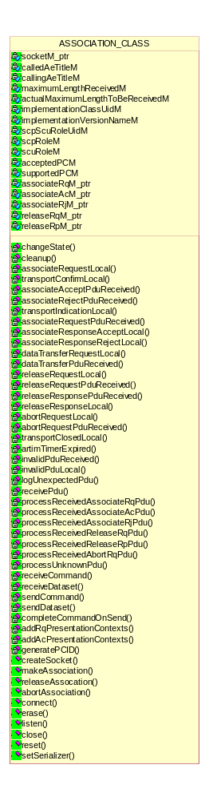
Figure 1 Class diagram of Association

Association Request class
The establishment of an association between two AEs shall be performed through ACSE A-ASSOCIATE request, indication, response and confirmation primitives.
It shall be a confirmed service.
The class ASSOCIATE_RQ_CLASS implements the A-ASSOCIATE request.
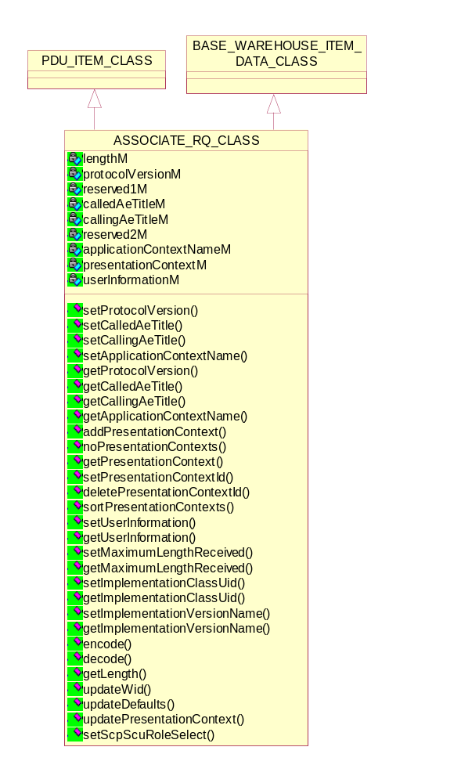
Figure 2 Class diagram of Association Request

Setting/Getting the Protocol Version
void setProtocolVersion(UINT16 protocolVersion)
UINT16 getProtocolVersion();

Setting/Getting the Called AE Title
void setCalledAeTitle(char*);
char* getCalledAeTitle();

Setting/Getting the Calling AE Title
void setCallingAeTitle(char*);
char* getCallingAeTitle();

Setting/Getting the Application Context Name
void setApplicationContextName(BYTE* uid_ptr, UINT32 length)
UID_CLASS& getApplicationContextName()

Setting the Presentation Context Id
void setPresentationContextId(UINT i, BYTE pcId);

Deleting the Presentation Context Id
void deletePresentationContextId(UINT i);

Sort Presentation Context ID’s in ascending order
void sortPresentationContexts();

Setting/Getting the User Information
void setUserInformation(USER_INFORMATION_CLASS& user_information);
USER_INFORMATION_CLASS& getUserInformation();

Setting/Getting the Maximum Length received
void setMaximumLengthReceived(UINT32 maximumLengthReceived);
UINT32 getMaximumLengthReceived();

Setting/Getting the Implementation Context Id
void setImplementationClassUid(char *implementationClassUid_ptr);
char *getImplementationClassUid();

Setting/Getting the Implementation Version Name
void setImplementationVersionName(char *implementationVersionName_ptr);
char *getImplementationVersionName();

Check that all parameters have been defined
void updateDefaults();

Encoding associate request as PDU
bool encode(PDU_CLASS&);
Return value | Explanation
true | The operation is successful.
false | The operation is failed.

Decoding associate request from PDU
bool decode(PDU_CLASS&);
Return value | Explanation
true | The operation is successful.
false | The operation is failed.

Getting PDU length
UINT32 getLength();

Setting the presentation context ids contains a zero value
void setZeroPresentationContextIds(ASSOCIATE_AC_CLASS*);

Updating the object in Warehouse
bool updateWid(BASE_WAREHOUSE_ITEM_DATA_CLASS*);

Return value | Explanation
true | The operation is successful.
false | The operation is failed.

Updating the presentation context
bool updatePresentationContext(ASSOCIATE_AC_CLASS*);

Return value | Explanation
true | The operation is successful.
false | The operation is failed.

Getting the SCP and SCU Role for the given SOP Class UID
bool getScpScuRoleSelect(UID_CLASS, BYTE*, BYTE*);

Return value | Explanation
true | The operation is successful.
false | The operation is failed.

Association Accept class
The establishment of an association between two AEs shall be performed through ACSE A-ASSOCIATE request, indication, response and confirmation primitives. The initiator of the service is hereafter called a requestor and the service-user, which

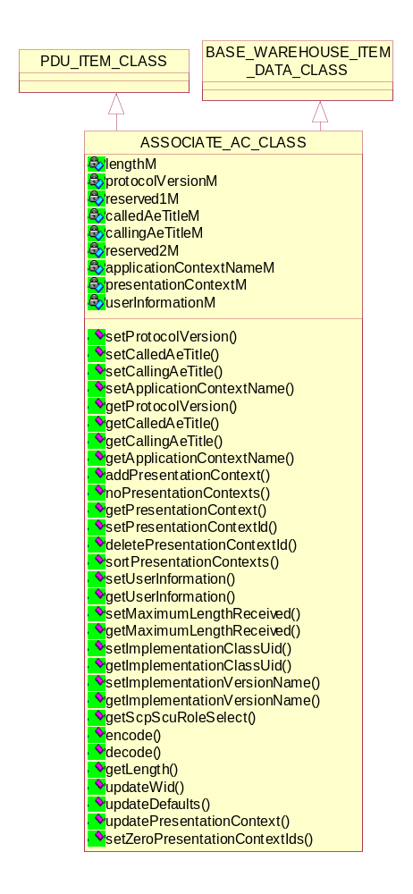
Figure 3 Class diagram of Association Accept
receives the A-ASSOCIATE indication, is hereafter called the acceptor. It shall be a confirmed service.
The class ASSOCIATE_AC_CLASS implements the A-ASSOCIATE accept.

Setting/Getting the Protocol Version
void setProtocolVersion(UINT16 protocolVersion);
UINT16 getProtocolVersion();

Setting/Getting the Called AE Title
void setCalledAeTitle(char*);
char* getCalledAeTitle();

Setting/Getting the Calling AE Title
void setCallingAeTitle(char*);
char* getCallingAeTitle();

Setting/Getting the Application Context Name
void setApplicationContextName(BYTE* uid_ptr, UINT32 length);
UID_CLASS& getApplicationContextName();

Setting/Getting the Presentation Context Id
void setPresentationContextId(UINT i, BYTE pcId);

Deleting the Presentation Context Id
void deletePresentationContextId(UINT i);

Sorting Presentation Context ID’s in ascending order
void sortPresentationContexts();

Setting/Getting the User Information
void setUserInformation(USER_INFORMATION_CLASS& user_information);
USER_INFORMATION_CLASS& getUserInformation();

Setting/Getting the Maximum Length received
void setMaximumLengthReceived(UINT32 maximumLengthReceived);
UINT32 getMaximumLengthReceived();

Setting/Getting the Implementation Context Id
void setImplementationClassUid(char *implementationClassUid_ptr);
char *getImplementationClassUid();

Setting/Getting the Implementation Version Name
void setImplementationVersionName(char *implementationVersionName_ptr);
char *getImplementationVersionName();

Checking that all parameters have been defined
void updateDefaults();

Encoding associate accept as PDU
bool encode(PDU_CLASS&);
Return value | Explanation
true | The operation is successful.
false | The operation is failed.

Decoding associate accept from PDU
bool decode(PDU_CLASS&);
Return value | Explanation
true | The operation is successful.
false | The operation is failed.

Getting PDU length
UINT32 getLength();

Setting the presentation context ids contains a zero value
void setZeroPresentationContextIds(ASSOCIATE_AC_CLASS*);

Updating the object in Warehouse
bool updateWid(BASE_WAREHOUSE_ITEM_DATA_CLASS*);

Return value | Explanation
true | The operation is successful.
false | The operation is failed.

Updating the presentation context
bool updatePresentationContext(ASSOCIATE_AC_CLASS*);

Return value | Explanation
true | The operation is successful.
false | The operation is failed.

Getting the SCP and SCU Role for the given SOP Class UID
bool getScpScuRoleSelect(UID_CLASS, BYTE*, BYTE*);

Return value | Explanation
true | The operation is successful.
false | The operation is failed.

Associate Reject class
This class ASSOCIATE_RJ_CLASS implements the A-ASSOCIATE reject.
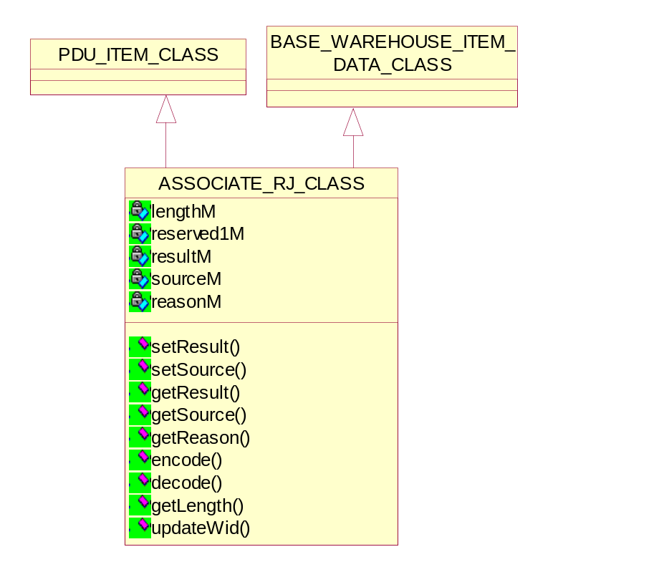
Figure 4 Class diagram of Associate Reject

Setting/Getting the source of association reject
void setSource(BYTE source);
BYTE getSource();

Setting/Getting the reason of association reject
void setReason(BYTE reason);
BYTE getReason();

Setting/Getting the result
void setResult(BYTE result)
BYTE getResult();

Encoding associate reject as PDU
bool encode(PDU_CLASS&);
Return value | Explanation
true | The operation is successful.
false | The operation is failed.

Decoding associate reject from PDU
bool decode(PDU_CLASS&);
Return value | Explanation
true | The operation is successful.
false | The operation is failed.

Getting PDU length
UINT32 getLength();

Updating the object in Warehouse
bool updateWid(BASE_WAREHOUSE_ITEM_DATA_CLASS*);

Return value | Explanation
true | The operation is successful.
false | The operation is failed.

Detail Design of Abort Request class
The ACSE A-ABORT service shall be used by a requestor in either of the AEs to cause the abnormal release of the association. It shall be a non-confirmed service. The abort shall be performed through A-ABORT request and A-ABORT indication primitives.
The class ABORT_RQ_CLASS implements the A-ABORT request.
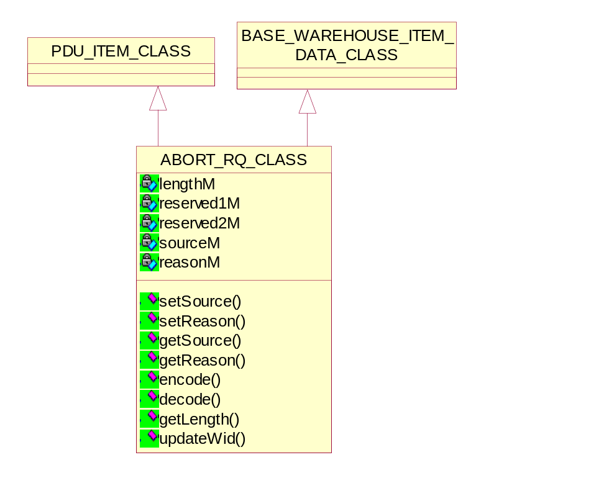
Figure 5 Class diagram of Abort Request

Setting/Getting the source of aborting
void setSource(BYTE source);
BYTE getSource();

Setting/Getting the reason of aborting
void setReason(BYTE reason);
BYTE getReason();

Encoding abort request as PDU
bool encode(PDU_CLASS&);
Return value | Explanation
true | The operation is successful.
false | The operation is failed.

Decoding abort request from PDU
bool decode(PDU_CLASS&);
Return value | Explanation
true | The operation is successful.
false | The operation is failed.

Getting PDU length
UINT32 getLength();

Updating the object in Warehouse
bool updateWid(BASE_WAREHOUSE_ITEM_DATA_CLASS*);

Return value | Explanation
true | The operation is successful.
false | The operation is failed.

Detail Design of Association Release classes
The graceful release of an association between two AEs shall be performed through ACSE A-RELEASE request, indication, response, and confirmation primitives. The initiator of the service is hereafter called a requestor and the service-user which receives the A-RELEASE indication is hereafter called the acceptor. It shall be a confirmed service.

Association Release Request class
The class RELEASE_RQ_CLASS implements the A-RELEASE request.

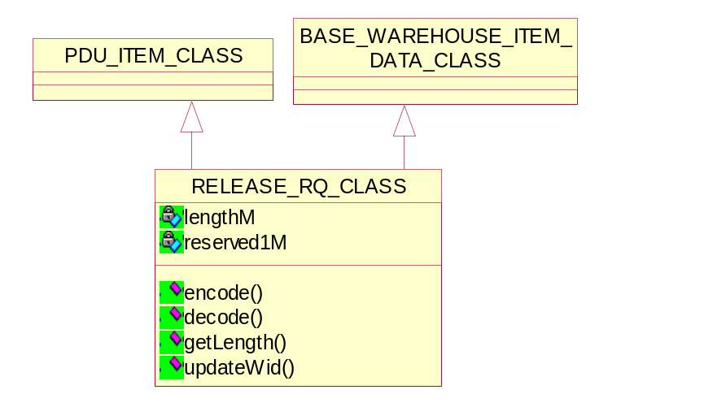
Figure 6 Class diagram of Release Request

Encoding release request as PDU
bool encode(PDU_CLASS&);
Return value | Explanation
true | The operation is successful.
false | The operation is failed.

Decoding release request from PDU
bool decode(PDU_CLASS&);
Return value | Explanation
true | The operation is successful.
false | The operation is failed.

Getting PDU length
UINT32 getLength();

Updating the object in Warehouse
bool updateWid(BASE_WAREHOUSE_ITEM_DATA_CLASS*);

Return value | Explanation
true | The operation is successful.
false | The operation is failed.

Association Release Response class
The class RELEASE_RP_CLASS implements the A-RELEASE response.

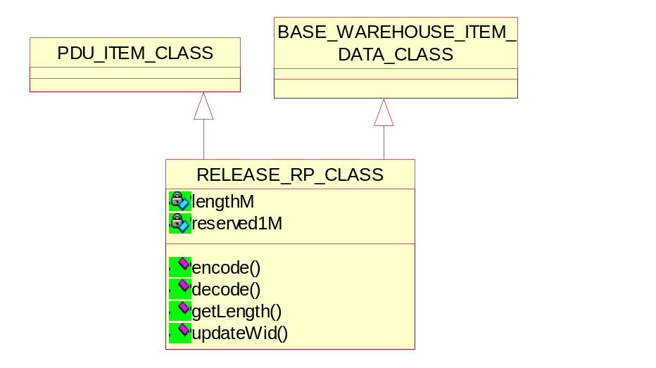
Figure 7 Class diagram of Release Response

Encoding release response as PDU
bool encode(PDU_CLASS&);
Return value | Explanation
true | The operation is successful.
false | The operation is failed.

Decoding release response from PDU
bool decode(PDU_CLASS&);
Return value | Explanation
true | The operation is successful.
false | The operation is failed.

Getting PDU length
UINT32 getLength();

Updating the object in Warehouse
bool updateWid(BASE_WAREHOUSE_ITEM_DATA_CLASS*);

Return value | Explanation
true | The operation is successful.
false | The operation is failed.

Detail Design of Unknown PDU class
This Presentation P-DATA Service shall be used by either AE to cause the exchange of application information (i.e. DICOM Messages). An association provides a simultaneous bi-directional exchange of P-DATA request/indication primitives.
The class UNKNOWN_PDU_CLASS implements the P-DATA Service.

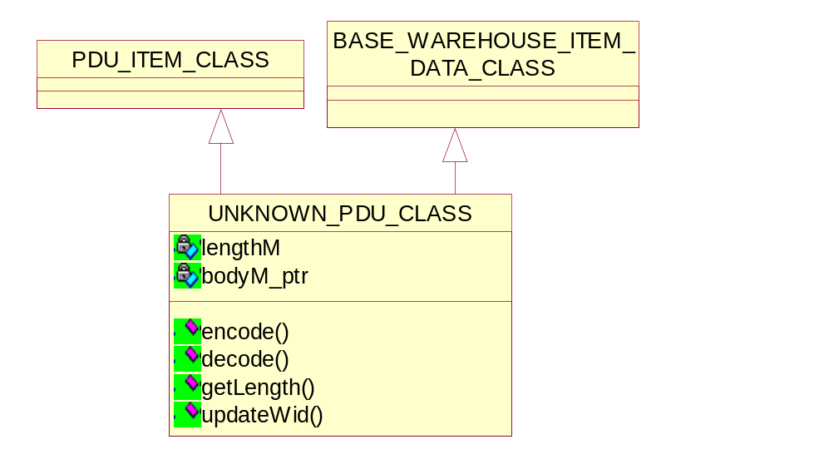
Figure 8 Class diagram of Unknown PDU

Encoding Unknown PDU
bool encode(PDU_CLASS&);
Return value | Explanation
true | The operation is successful.
false | The operation is failed.

Decoding Unknown PDU
bool decode(PDU_CLASS&);
Return value | Explanation
true | The operation is successful.
false | The operation is failed.

Getting PDU length
UINT32 getLength();

Updating the object in Warehouse
bool updateWid(BASE_WAREHOUSE_ITEM_DATA_CLASS*);

Return value | Explanation
true | The operation is successful.
false | The operation is failed.

Detail Design of DULP State class
The Finite State Machine will be implemented by the DULP_STATE_CLASS. This will make use of the “State” pattern [PATTERNS].
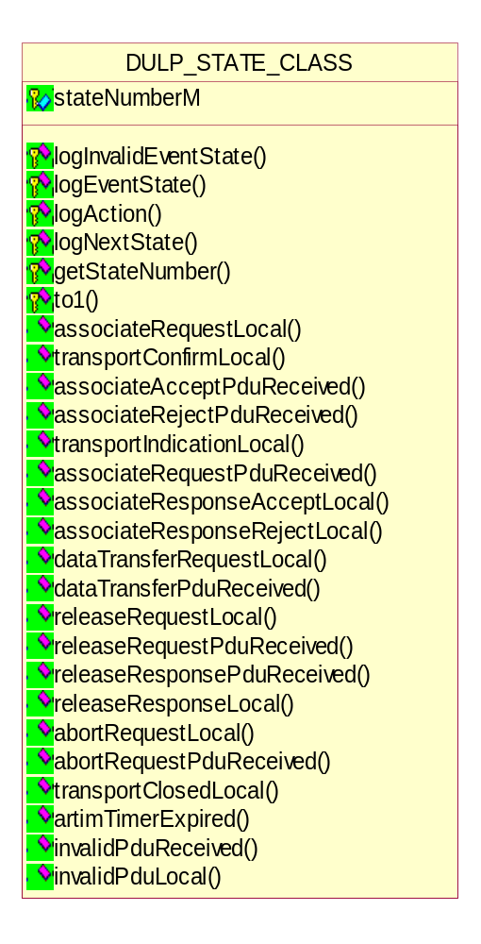
Figure 9 Class diagram of DULP state

DULP State Machine

Machine States Definition

No Association
State | Definition
Sta 1 | Idle

Association Establishment
State | Definition
Sta 2 | Transport connection open (Awaiting A-ASSOCIATE-RQ PDU)
Sta 3 | Awaiting local A-ASSOCIATE response primitive (from local user)
Sta 4 | Awaiting transport connection opening to complete (from local transport service)
Sta 5 | Awaiting A-ASSOCIATE-AC or A-ASSOCIATE-RJ PDU

Data Transfer
State | Definition
Sta 6 | Association established and ready for data transfer

Association Release
State | Definition
Sta 7 | Awaiting A-RELEASE-RP PDU
Sta 8 | Awaiting local A RELEASE response primitive (from local user)
Sta 9 | Release collision requestor side; awaiting A-RELEASE response (from local user)
Sta 10 | Release collision acceptor side; awaiting A-RELEASE-RP PDU
Sta 11 | Release collision requestor side; awaiting A-RELEASE-RP PDU
Sta 12 | Release collision acceptor side; awaiting A-RELEASE response primitive (from local user)

Waiting for Transport Connection Close
State | Definition
Sta 13 | Awaiting Transport Connection Close Indication (Association no longer exists)

State Machine Actions Definition and their implementation

Association Establishment Related Actions
State | Definition
AE-1 | Issue TRANSPORT CONNECT request primitive to local transport service  Next state is Sta4
AE-2 | Send A-ASSOCIATE-RQ-PDU  Next state is Sta5
AE-3 | Issue A-ASSOCIATE confirmation (accept) primitive  Next state is Sta6
AE-4 | Issue A-ASSOCIATE confirmation (reject) primitive and close transport connection  Next state is Sta1
AE-5 | Issue Transport connection response primitive; start ARTIM timer  Next state is Sta2
AE-6 | Stop ARTIM timer and if A-ASSOCIATE-RQ acceptable by service-provider:  - issue A-ASSOCIATE indication primitive  Next state is Sta3  otherwise:  -issue A-ASSOCIATE-RJ-PDU and start ARTIM timer  Next state is Sta13
AE-7 | Send A-ASSOCIATE-AC PDU  Next state is Sta6
AE-8 | Send A-ASSOCIATE-RJ PDU and start ARTIM timer  Next state is STA13

// Association establishment actions
// Issue Transport Connect request primitive
bool ae1(ASSOCIATION_CLASS*, DULP_STATE_CLASS*);
// Send A-ASSOCIATE-RQ PDU
bool ae2(ASSOCIATION_CLASS*, DULP_STATE_CLASS*);
// Issue A-ASSOCIATE confirmation (accept) primitive
bool ae3(ASSOCIATION_CLASS*, DULP_STATE_CLASS*, PDU_CLASS*);
// Issue A-ASSOCIATE confirmation (reject) primitive
bool ae4(ASSOCIATION_CLASS*, DULP_STATE_CLASS*, PDU_CLASS*);
// Issue Transport Connection response
bool ae5(ASSOCIATION_CLASS*, DULP_STATE_CLASS*);
// Issue A-ASSOCIATE indication primitive
bool ae6(ASSOCIATION_CLASS*, DULP_STATE_CLASS*, PDU_CLASS*);
// Send A-ASSOCIATE-AC PDU
bool ae7(ASSOCIATION_CLASS*, DULP_STATE_CLASS*);
// Send A-ASSOCIATE-RJ PDU
bool ae8(ASSOCIATION_CLASS*, DULP_STATE_CLASS*);

Data Transfer Related Actions
State | Definition
DT-1 | Send P-DATA-TF PDU  Next state is Sta6
DT-2 | Send P-DATA indication primitive  Next state is Sta6
// Data transfer actions
// Send P-DATA-TF PDU
bool dt1(ASSOCIATION_CLASS*, DULP_STATE_CLASS*, DATA_TF_PDU_CLASS*);
// Issue P-DATA indication primitive
bool dt2(ASSOCIATION_CLASS*, DULP_STATE_CLASS*, DATA_TF_PDU_CLASS*);

Association Release Related Actions
State | Definition
AR-1 | Send A-RELEASE-RQ PDU  Next state is Sta7
AR-2 | Issue A-RELEASE indication primitive  Next state is Sta8
AR-3 | Issue A-RELEASE confirmation primitive, and close transport connection  Next state is Sta1
AR-4 | Issue A-RELEASE-RP PDU and start ARTIM timer  Next state is Sta13
AR-5 | Stop ARTIM timer  Next state is Sta1
AR-6 | Issue P-DATA indication  Next state is Sta7
AR-7 | Issue P-DATA-TF PDU  Next state is Sta8
AR-8 | Issue A-RELEASE indication (release collision):  - if association-requestor, next state is Sta9  - if not, next state is Sta10
AR-9 | Send A-RELEASE-RP PDU  Next state is Sta11
AR-10 | Issue A-RELEASE confirmation primitive  Next state is Sta12

// Association release related actions
// Send A-RELEASE-RQ PDU
bool ar1(ASSOCIATION_CLASS*, DULP_STATE_CLASS*);
// Issue A-RELEASE indication primitive
bool ar2(ASSOCIATION_CLASS*, DULP_STATE_CLASS*, PDU_CLASS*);
// Issue A-RELEASE confirmation primitive
bool ar3(ASSOCIATION_CLASS*, DULP_STATE_CLASS*, PDU_CLASS*);
// Send A-RELEASE-RP PDU
bool ar4(ASSOCIATION_CLASS*, DULP_STATE_CLASS*);
// Stop ARTIM timer
bool ar5(ASSOCIATION_CLASS*, DULP_STATE_CLASS*);
// Issue P-DATA Indication
bool ar6(ASSOCIATION_CLASS*, DULP_STATE_CLASS*, PDU_CLASS*);
// Send P-DATA-TF PDU
bool ar7(ASSOCIATION_CLASS*, DULP_STATE_CLASS*, DATA_TF_PDU_CLASS*);
// Issue A-RELEASE indication
bool ar8(ASSOCIATION_CLASS*, DULP_STATE_CLASS*, PDU_CLASS*);
// Send A-RELEASE-RP PDU
bool ar9(ASSOCIATION_CLASS*, DULP_STATE_CLASS*);
// Issue A-RELEASE confirmation
bool ar10(ASSOCIATION_CLASS*, DULP_STATE_CLASS*, PDU_CLASS*);

Association Abort Related Actions
State | Definition
AA-1 | Send A-ABORT PDU (service-user source) and start (or restart if already started) ARTIM  timer;  Next state is Sta13
AA-2 | Stop ARTIM timer if running. Close transport connection  Next state is Sta1
AA-3 | If (service-user inititated abort)  - issue A-ABORT indication and close transport connection  otherwise (service-provider inititated abort):  - issue A-P-ABORT indication and close transport connection  Next state is Sta1
AA-4 | Issue A-P-ABORT indication primitive,  Next state is Sta1
AA-5 | Stop ARTIM timer,  Next state is Sta1
AA-6 | Ignore PDU,  Next state is Sta13
AA-7 | Send A-ABORT PDU,  Next state is Sta13
AA-8 | Send A-ABORT PDU (service-provider source-), issue an A-P-ABORT indication, and start ARTIM  timer;  Nest state is Sta13

// Association abort related actions
// Send A-ABORT-RQ PDU
bool aa1(ASSOCIATION_CLASS*, DULP_STATE_CLASS*, PDU_CLASS *pdu_ptr = NULL);
// Stop ARTIM timer
bool aa2(ASSOCIATION_CLASS*, DULP_STATE_CLASS*, PDU_CLASS *pdu_ptr = NULL);
// Issue A-(P-)Abort indication
bool aa3(ASSOCIATION_CLASS*, DULP_STATE_CLASS*, PDU_CLASS*);
// Issue A-P-Abort indication primitive
bool aa4(ASSOCIATION_CLASS*, DULP_STATE_CLASS*);
// Stop ARTIM timer
bool aa5(ASSOCIATION_CLASS*, DULP_STATE_CLASS*);
// Ignore PDU
bool aa6(ASSOCIATION_CLASS*, DULP_STATE_CLASS*, PDU_CLASS*);
// Send A-ABORT-RQ PDU
bool aa7(ASSOCIATION_CLASS*, DULP_STATE_CLASS*, PDU_CLASS*);
// Send A-ABORT-RQ PDU
bool aa8(ASSOCIATION_CLASS*, DULP_STATE_CLASS*, PDU_CLASS*);

Logging the Event and State combination
void logEventState(LOG_CLASS*, int);

Logging the action
void logAction(LOG_CLASS*, int);

Logging the Invalid Event and State combination
bool logInvalidEventState(LOG_CLASS*, int);
Return value | Explanation
true | The operation is successful.
false | The operation is failed.

Action TO-1 - Test Only - Send Unknown PDU
bool to1(ASSOCIATION_CLASS*);
Return value | Explanation
true | The operation is successful.
false | The operation is failed.

Logging the next state change
void logNextState(LOG_CLASS*, int);

Getting the state number
int getStateNumber();

DULP events
The following DULP events methods implemented in derived DULP states classes. The base DULP_STATE class only provides default implementation.
virtual bool associateRequestLocal(ASSOCIATION_CLASS *association_ptr);
virtual bool transportConfirmLocal(ASSOCIATION_CLASS *association_ptr);
virtual bool associateAcceptPduReceived(ASSOCIATION_CLASS *association_ptr, PDU_CLASS*);
virtual bool associateRejectPduReceived(ASSOCIATION_CLASS *association_ptr, PDU_CLASS*);
virtual bool transportIndicationLocal(ASSOCIATION_CLASS *association_ptr);
virtual bool associateRequestPduReceived(ASSOCIATION_CLASS *association_ptr, PDU_CLASS*);
virtual bool associateResponseAcceptLocal(ASSOCIATION_CLASS *association_ptr);
virtual bool associateResponseRejectLocal(ASSOCIATION_CLASS *association_ptr);
virtual bool dataTransferRequestLocal(ASSOCIATION_CLASS *association_ptr, DATA_TF_PDU_CLASS*);
virtual bool dataTransferPduReceived(ASSOCIATION_CLASS *association_ptr, DATA_TF_PDU_CLASS*);
virtual bool releaseRequestLocal(ASSOCIATION_CLASS *association_ptr);
virtual bool releaseRequestPduReceived(ASSOCIATION_CLASS *association_ptr, PDU_CLASS*);
virtual bool releaseResponsePduReceived(ASSOCIATION_CLASS *association_ptr, PDU_CLASS*);
virtual bool releaseResponseLocal(ASSOCIATION_CLASS *association_ptr);
virtual bool abortRequestLocal(ASSOCIATION_CLASS *association_ptr);
virtual bool abortRequestPduReceived(ASSOCIATION_CLASS *association_ptr, PDU_CLASS*);
virtual bool transportClosedLocal(ASSOCIATION_CLASS *association_ptr);
virtual bool artimTimerExpired(ASSOCIATION_CLASS *association_ptr);
virtual bool invalidPduReceived(ASSOCIATION_CLASS *association_ptr, PDU_CLASS*);
virtual bool invalidPduLocal(ASSOCIATION_CLASS*);

Derived Classes Of DULP State class

State1 class
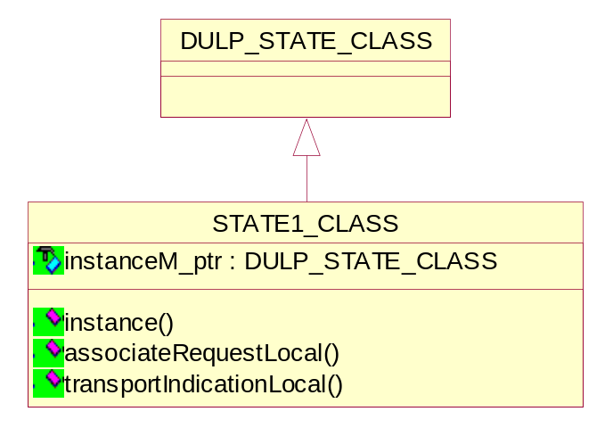
Figure 10 Class Diagram of State1

Event handlers
// Handle event and switch state to ae1
bool associateRequestLocal(ASSOCIATION_CLASS*);
// Handle event and switch state to ae5
bool transportIndicationLocal(ASSOCIATION_CLASS*);

State2 class

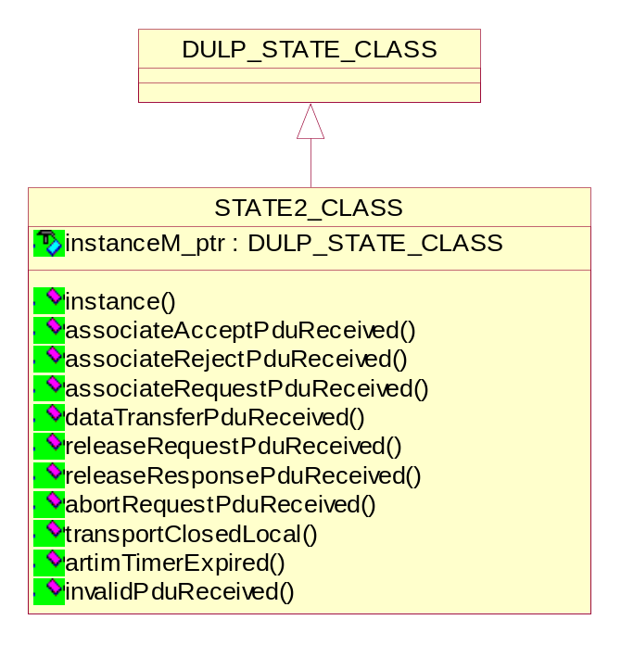
Figure 11 Class Diagram of State2

Event handlers
// Handle event and switch state to aa1
bool associateAcceptPduReceived(ASSOCIATION_CLASS*, PDU_CLASS*);
// Handle event and switch state to aa1
bool associateRejectPduReceived(ASSOCIATION_CLASS*, PDU_CLASS*);
// Handle event and switch state to aa6
bool associateRequestPduReceived(ASSOCIATION_CLASS*, PDU_CLASS*);
// Handle event and switch state to aa1
bool dataTransferPduReceived(ASSOCIATION_CLASS*, DATA_TF_PDU_CLASS*);
// Handle event and switch state to aa1
bool releaseRequestPduReceived(ASSOCIATION_CLASS*, PDU_CLASS*);
// Handle event and switch state to aa1
bool releaseResponsePduReceived(ASSOCIATION_CLASS*, PDU_CLASS*);
// Handle event and switch state to aa2
bool abortRequestPduReceived(ASSOCIATION_CLASS*, PDU_CLASS*);
// Handle event and switch state to aa5
bool transportClosedLocal(ASSOCIATION_CLASS*);
// Handle event and switch state to aa2
bool artimTimerExpired(ASSOCIATION_CLASS*);
// Handle event and switch state to aa1
bool invalidPduReceived(ASSOCIATION_CLASS*, PDU_CLASS*);

State3 class
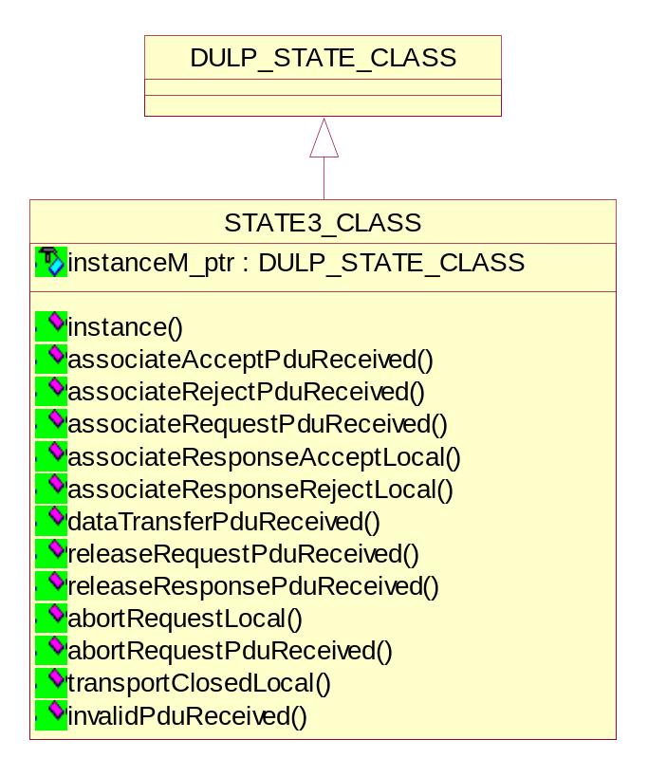
Figure 12 Class Diagram of State3

Event handlers
// Handle event and switch state to aa8
bool associateAcceptPduReceived(ASSOCIATION_CLASS*, PDU_CLASS*);
// Handle event and switch state to aa8
bool associateRejectPduReceived(ASSOCIATION_CLASS*, PDU_CLASS*);
// Handle event and switch state to ae7
bool associateResponseAcceptLocal(ASSOCIATION_CLASS*);
// Handle event and switch state to ae8
bool associateResponseRejectLocal(ASSOCIATION_CLASS*);
// Handle event and switch state to aa8
bool associateRequestPduReceived(ASSOCIATION_CLASS*, PDU_CLASS*);
// Handle event and switch state to aa8
bool dataTransferPduReceived(ASSOCIATION_CLASS*, DATA_TF_PDU_CLASS*);
// Handle event and switch state to aa8
bool releaseRequestPduReceived(ASSOCIATION_CLASS*, PDU_CLASS*);
// Handle event and switch state to aa8
bool releaseResponsePduReceived(ASSOCIATION_CLASS*, PDU_CLASS*);
// Handle event and switch state to aa3
bool abortRequestPduReceived(ASSOCIATION_CLASS*, PDU_CLASS*);
// Handle event and switch state to aa5
bool transportClosedLocal(ASSOCIATION_CLASS*);
// Handle event and switch state to aa4
bool abortRequestLocal(ASSOCIATION_CLASS*);
// Handle event and switch state to aa8
bool invalidPduReceived(ASSOCIATION_CLASS*, PDU_CLASS*);

State4 class

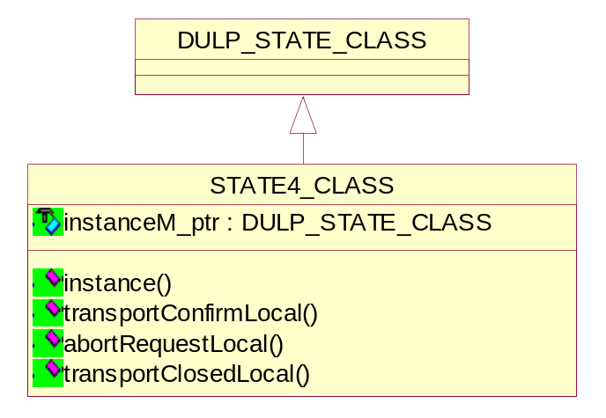
Figure 13 Class Diagram of State4

Event handlers
// Handle event and switch state to ae2
bool transportConfirmLocal(ASSOCIATION_CLASS*);
// Handle event and switch state to aa2
bool abortRequestLocal(ASSOCIATION_CLASS*);
// Handle event and switch state to aa4
bool transportClosedLocal(ASSOCIATION_CLASS*);

State5 class

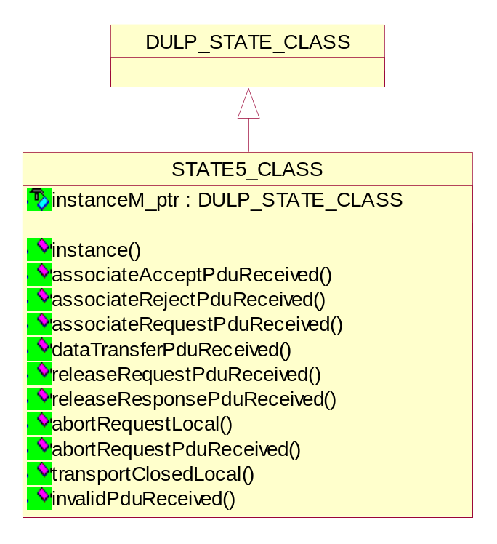
Figure 14 Class Diagram of State5

Event handlers
// Handle event and switch state to ae3
bool associateAcceptPduReceived(ASSOCIATION_CLASS*, PDU_CLASS*);
// Handle event and switch state to ae4
bool associateRejectPduReceived(ASSOCIATION_CLASS*, PDU_CLASS*);
// Handle event and switch state to aa8
bool associateRequestPduReceived(ASSOCIATION_CLASS*, PDU_CLASS*);
// Handle event and switch state to aa8
bool dataTransferPduReceived(ASSOCIATION_CLASS*, DATA_TF_PDU_CLASS*);
// Handle event and switch state to aa8
bool releaseRequestPduReceived(ASSOCIATION_CLASS*, PDU_CLASS*);
// Handle event and switch state to aa8
bool releaseResponsePduReceived(ASSOCIATION_CLASS*, PDU_CLASS*);
// Handle event and switch state to aa3
bool abortRequestPduReceived(ASSOCIATION_CLASS*, PDU_CLASS*);
// Handle event and switch state to aa1
bool abortRequestLocal(ASSOCIATION_CLASS*);
// Handle event and switch state to aa4
bool transportClosedLocal(ASSOCIATION_CLASS*);
// Handle event and switch state to aa8
bool invalidPduReceived(ASSOCIATION_CLASS*, PDU_CLASS*);

State6 class

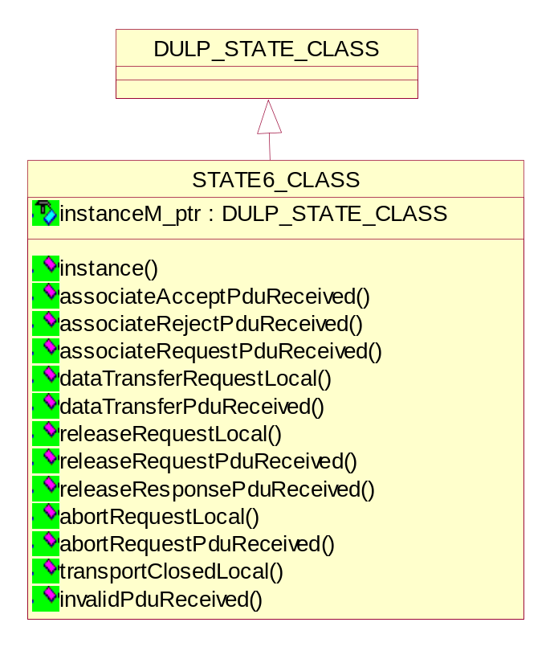
Figure 15 Class Diagram of State6

Event handlers
// Handle event and switch state to aa8
bool associateAcceptPduReceived(ASSOCIATION_CLASS*, PDU_CLASS*);
// Handle event and switch state to aa8
bool associateRejectPduReceived(ASSOCIATION_CLASS*, PDU_CLASS*);
// Handle event and switch state to aa8
bool associateRequestPduReceived(ASSOCIATION_CLASS*, PDU_CLASS*);
// Handle event and switch state to dt1
bool dataTransferRequestLocal(ASSOCIATION_CLASS*, DATA_TF_PDU_CLASS*);
// Handle event and switch state to dt2
bool dataTransferPduReceived(ASSOCIATION_CLASS*, DATA_TF_PDU_CLASS*);
// Handle event and switch state to ar1
bool releaseRequestLocal(ASSOCIATION_CLASS*, PDU_CLASS*);
// Handle event and switch state to ar2
bool releaseRequestPduReceived(ASSOCIATION_CLASS*, PDU_CLASS*);
// Handle event and switch state to aa8
bool releaseResponsePduReceived(ASSOCIATION_CLASS*, PDU_CLASS*);
// Handle event and switch state to aa3
bool abortRequestPduReceived(ASSOCIATION_CLASS*, PDU_CLASS*);
// Handle event and switch state to aa1
bool abortRequestLocal(ASSOCIATION_CLASS*);
// Handle event and switch state to aa4
bool transportClosedLocal(ASSOCIATION_CLASS*);
// Handle event and switch state to aa8
bool invalidPduReceived(ASSOCIATION_CLASS*, PDU_CLASS*);

State7 class

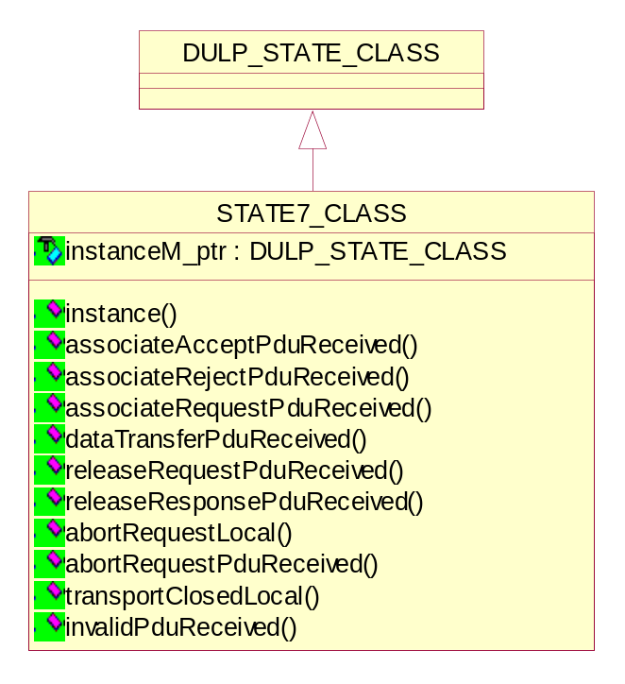
Figure 16 Class Diagram of State7

Event handlers
// Handle event and switch state to aa8
bool associateAcceptPduReceived(ASSOCIATION_CLASS*, PDU_CLASS*);
// Handle event and switch state to aa8
bool associateRejectPduReceived(ASSOCIATION_CLASS*, PDU_CLASS*);
// Handle event and switch state to aa8
bool associateRequestPduReceived(ASSOCIATION_CLASS*, PDU_CLASS*);
// Handle event and switch state to ar6
bool dataTransferPduReceived(ASSOCIATION_CLASS*, DATA_TF_PDU_CLASS*);
// Handle event and switch state to ar8
bool releaseRequestPduReceived(ASSOCIATION_CLASS*, PDU_CLASS*);
// Handle event and switch state to ar3
bool releaseResponsePduReceived(ASSOCIATION_CLASS*, PDU_CLASS*);
// Handle event and switch state to aa3
bool abortRequestPduReceived(ASSOCIATION_CLASS*, PDU_CLASS*);
// Handle event and switch state to aa1
bool abortRequestLocal(ASSOCIATION_CLASS*);
// Handle event and switch state to aa4
bool transportClosedLocal(ASSOCIATION_CLASS*);
// Handle event and switch state to aa8
bool invalidPduReceived(ASSOCIATION_CLASS*, PDU_CLASS*);

State8 class

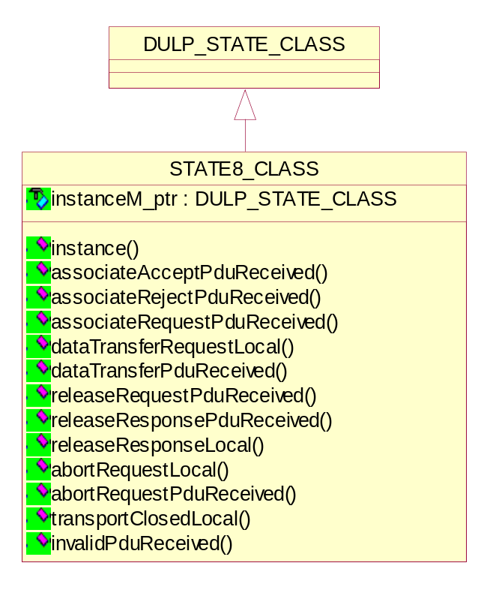
Figure 17 Class Diagram of State8

Event handlers
// Handle event and switch state to aa8
bool associateAcceptPduReceived(ASSOCIATION_CLASS*, PDU_CLASS*);
// Handle event and switch state to aa8
bool associateRejectPduReceived(ASSOCIATION_CLASS*, PDU_CLASS*);
// Handle event and switch state to aa8
bool associateRequestPduReceived(ASSOCIATION_CLASS*, PDU_CLASS*);
// Handle event and switch state to ar7
bool dataTransferRequestLocal(ASSOCIATION_CLASS*, DATA_TF_PDU_CLASS*);
// Handle event and switch state to aa8
bool dataTransferPduReceived(ASSOCIATION_CLASS*, DATA_TF_PDU_CLASS*);
// Handle event and switch state to ar4
bool releaseRequestLocal(ASSOCIATION_CLASS*, PDU_CLASS*);
// Handle event and switch state to aa8
bool releaseRequestPduReceived(ASSOCIATION_CLASS*, PDU_CLASS*);
// Handle event and switch state to aa8
bool releaseResponsePduReceived(ASSOCIATION_CLASS*, PDU_CLASS*);
// Handle event and switch state to aa3
bool abortRequestPduReceived(ASSOCIATION_CLASS*, PDU_CLASS*);
// Handle event and switch state to aa1
bool abortRequestLocal(ASSOCIATION_CLASS*);
// Handle event and switch state to aa4
bool transportClosedLocal(ASSOCIATION_CLASS*);
// Handle event and switch state to aa8
bool invalidPduReceived(ASSOCIATION_CLASS*, PDU_CLASS*);

State9 class

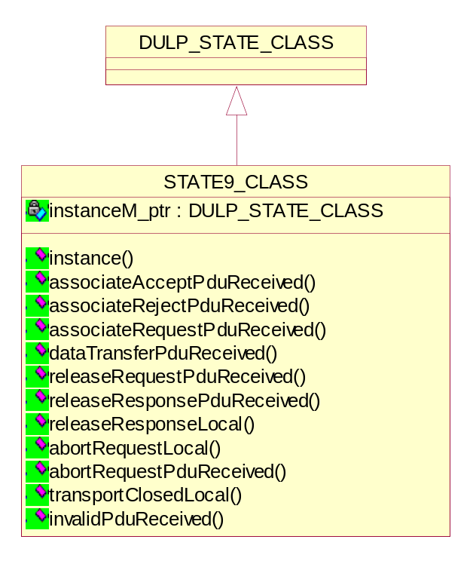
Figure 18 Class Diagram of State9

Event handlers
// Handle event and switch state to aa8
bool associateAcceptPduReceived(ASSOCIATION_CLASS*, PDU_CLASS*);
// Handle event and switch state to aa8
bool associateRejectPduReceived(ASSOCIATION_CLASS*, PDU_CLASS*);
// Handle event and switch state to aa8
bool associateRequestPduReceived(ASSOCIATION_CLASS*, PDU_CLASS*);
// Handle event and switch state to aa8
bool dataTransferPduReceived(ASSOCIATION_CLASS*, DATA_TF_PDU_CLASS*);
// Handle event and switch state to aa8
bool releaseRequestPduReceived(ASSOCIATION_CLASS*, PDU_CLASS*);
// Handle event and switch state to aa8
bool releaseResponsePduReceived(ASSOCIATION_CLASS*, PDU_CLASS*);
// Handle event and switch state to ar9
bool releaseResponseLocal(ASSOCIATION_CLASS*);
// Handle event and switch state to aa3
bool abortRequestPduReceived(ASSOCIATION_CLASS*, PDU_CLASS*);
// Handle event and switch state to aa1
bool abortRequestLocal(ASSOCIATION_CLASS*);
// Handle event and switch state to aa4
bool transportClosedLocal(ASSOCIATION_CLASS*);
// Handle event and switch state to aa8
bool invalidPduReceived(ASSOCIATION_CLASS*, PDU_CLASS*);

State10 class

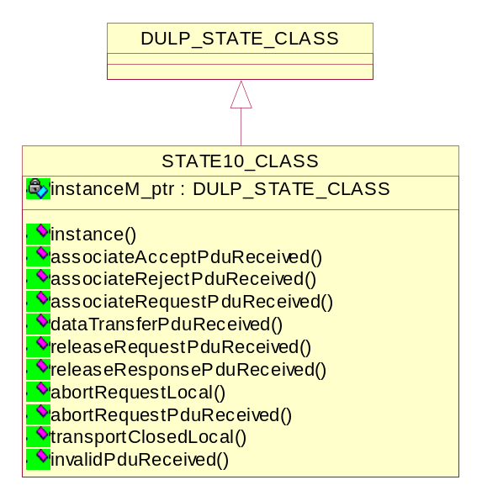
Figure 19 Class Diagram of State10

Event handlers
// Handle event and switch state to aa8
bool associateAcceptPduReceived(ASSOCIATION_CLASS*, PDU_CLASS*);
// Handle event and switch state to aa8
bool associateRejectPduReceived(ASSOCIATION_CLASS*, PDU_CLASS*);
// Handle event and switch state to aa8
bool associateRequestPduReceived(ASSOCIATION_CLASS*, PDU_CLASS*);
// Handle event and switch state to aa8
bool dataTransferPduReceived(ASSOCIATION_CLASS*, DATA_TF_PDU_CLASS*);
// Handle event and switch state to aa8
bool releaseRequestPduReceived(ASSOCIATION_CLASS*, PDU_CLASS*);
// Handle event and switch state to ar10
bool releaseResponsePduReceived(ASSOCIATION_CLASS*, PDU_CLASS*);
// Handle event and switch state to aa3
bool abortRequestPduReceived(ASSOCIATION_CLASS*, PDU_CLASS*);
// Handle event and switch state to aa1
bool abortRequestLocal(ASSOCIATION_CLASS*);
// Handle event and switch state to aa4
bool transportClosedLocal(ASSOCIATION_CLASS*);
// Handle event and switch state to aa8
bool invalidPduReceived(ASSOCIATION_CLASS*, PDU_CLASS*);

State11 class
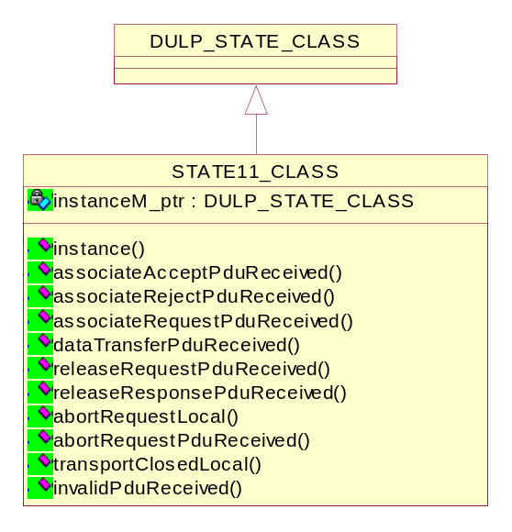
Figure 20 Class Diagram of State11

Event handlers
// Handle event and switch state to aa8
bool associateAcceptPduReceived(ASSOCIATION_CLASS*, PDU_CLASS*);
// Handle event and switch state to aa8
bool associateRejectPduReceived(ASSOCIATION_CLASS*, PDU_CLASS*);
// Handle event and switch state to aa8
bool associateRequestPduReceived(ASSOCIATION_CLASS*, PDU_CLASS*);
// Handle event and switch state to aa8
bool dataTransferPduReceived(ASSOCIATION_CLASS*, DATA_TF_PDU_CLASS*);
// Handle event and switch state to aa8
bool releaseRequestPduReceived(ASSOCIATION_CLASS*, PDU_CLASS*);
// Handle event and switch state to ar10
bool releaseResponsePduReceived(ASSOCIATION_CLASS*, PDU_CLASS*);
// Handle event and switch state to aa3
bool abortRequestPduReceived(ASSOCIATION_CLASS*, PDU_CLASS*);
// Handle event and switch state to aa1
bool abortRequestLocal(ASSOCIATION_CLASS*);
// Handle event and switch state to aa4
bool transportClosedLocal(ASSOCIATION_CLASS*);
// Handle event and switch state to aa8
bool invalidPduReceived(ASSOCIATION_CLASS*, PDU_CLASS*);

State12 class
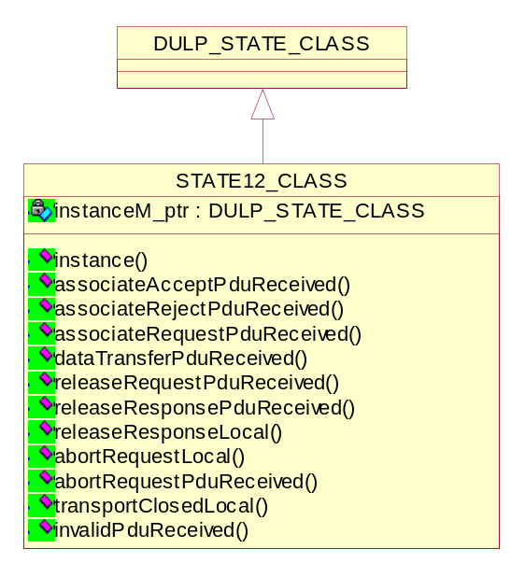
Figure 21 Class Diagram of State12

Event handlers
// Handle event and switch state to aa8
bool associateAcceptPduReceived(ASSOCIATION_CLASS*, PDU_CLASS*);
// Handle event and switch state to aa8
bool associateRejectPduReceived(ASSOCIATION_CLASS*, PDU_CLASS*);
// Handle event and switch state to aa8
bool associateRequestPduReceived(ASSOCIATION_CLASS*, PDU_CLASS*);
// Handle event and switch state to aa8
bool dataTransferPduReceived(ASSOCIATION_CLASS*, DATA_TF_PDU_CLASS*);
// Handle event and switch state to aa8
bool releaseRequestPduReceived(ASSOCIATION_CLASS*, PDU_CLASS*);
// Handle event and switch state to aa8
bool releaseResponsePduReceived(ASSOCIATION_CLASS*, PDU_CLASS*);
// Handle event and switch state to ar4
bool releaseResponseLocal(ASSOCIATION_CLASS*);
// Handle event and switch state to aa3
bool abortRequestPduReceived(ASSOCIATION_CLASS*, PDU_CLASS*);
// Handle event and switch state to aa1
bool abortRequestLocal(ASSOCIATION_CLASS*);
// Handle event and switch state to aa4
bool transportClosedLocal(ASSOCIATION_CLASS*);
// Handle event and switch state to aa8
bool invalidPduReceived(ASSOCIATION_CLASS*, PDU_CLASS*);

State13 class
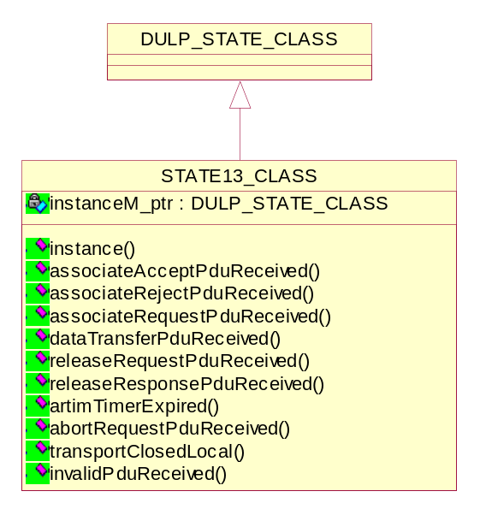
Figure 22 Class Diagram of State13

Event handlers
// Handle event and switch state to aa6
bool associateAcceptPduReceived(ASSOCIATION_CLASS*, PDU_CLASS*);
// Handle event and switch state to aa6
bool associateRejectPduReceived(ASSOCIATION_CLASS*, PDU_CLASS*);
// Handle event and switch state to aa7
bool associateRequestPduReceived(ASSOCIATION_CLASS*, PDU_CLASS*);
// Handle event and switch state to aa6
bool dataTransferPduReceived(ASSOCIATION_CLASS*, DATA_TF_PDU_CLASS*);
// Handle event and switch state to aa6
bool releaseRequestPduReceived(ASSOCIATION_CLASS*, PDU_CLASS*);
// Handle event and switch state to aa6
bool releaseResponsePduReceived(ASSOCIATION_CLASS*, PDU_CLASS*);
// Handle event and switch state to aa2
bool artimTimerExpired(ASSOCIATION_CLASS*);
// Handle event and switch state to aa2
bool abortRequestPduReceived(ASSOCIATION_CLASS*, PDU_CLASS*);
// Handle event and switch state to ar5
bool transportClosedLocal(ASSOCIATION_CLASS*);
// Handle event and switch state to aa7
bool invalidPduReceived(ASSOCIATION_CLASS*, PDU_CLASS*);

Various derived Classes Of PDU Item class
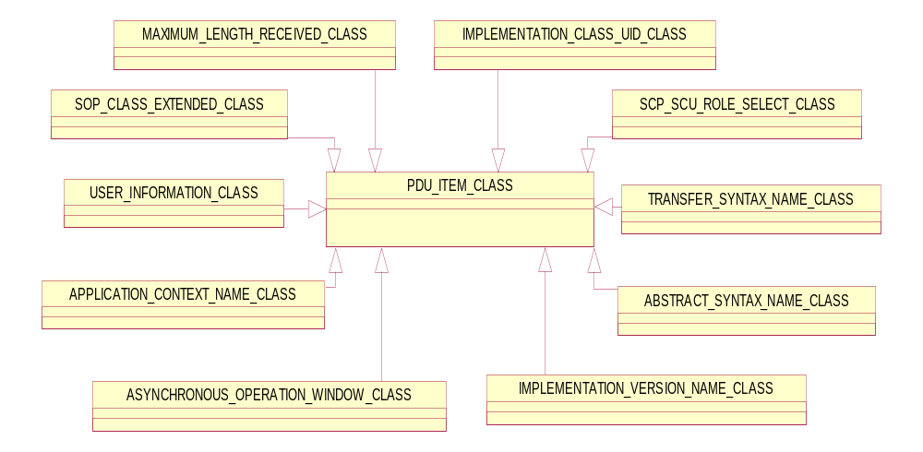
Figure 23 Class relationship diagram of PDU Item

PDU Item class
The Protocol Data Unit Item is the part of PDU. This s the abstract base class and provides default implementation. The derived classes provides specific implementation.

Application Context Name class
An application context explicitly defines the set of application service elements, related options and any other information necessary for the inter-working of Application Entities on an association.
Two Application Entities when establishing an association agree on an application context. The requestor of an association proposes an Application Context Name and the acceptor returns either the same or a different Application Context Name. The returned name specifies the application context to be used for this association. The offer of an alternate application context by the acceptor provides a mechanism for limited negotiation. If the requestor cannot operate in the acceptor's application context, it will issue an A-Abort request primitive. Such a negotiation will facilitate the introduction of future versions of the DICOM Application Entity.
This class indicates the Application context name and derived from PDU Item class.

Getting/Setting and checking the UID
void setUid(UID_CLASS&);
void setUid(BYTE*, UINT32);
void setUid(char*);
bool isUidValid();
UID_CLASS& getUid();

Decoding the Application Context Name
bool decode(PDU_CLASS&);
bool decodeBody(PDU_CLASS&);

Encoding the Application Context Name
bool encode(PDU_CLASS&);

Getting the length of Application Context Name
UINT32 getLength();

Updating default Application Context Name
void updateDefaults();

Abstract Syntax Name class
DICOM AEs use the Abstract Syntax Name to identify and negotiate which SOP Classes and related options are supported on a specific Association.
Each Abstract Syntax shall be identified by an abstract Syntax Name in the form of a UID. Abstract Syntax Names shall be defined in the Service Class Definitions specified in [DCM] part-4.
Each Abstract Syntax Name defined shall have a value of either-
- Service-Object Pair Class UID
- Meta Service-Object Pair Group UID
This class indicates the Abstract Syntax Name and derived from PDU Item class.

Getting/Setting and checking the UID
void setUid(UID_CLASS&);
void setUid(BYTE*, UINT32);
void setUid(char*);
bool isUidValid();
UID_CLASS& getUid();

Decoding the Abstract Syntax Name
bool decode(PDU_CLASS&);
bool decodeBody(PDU_CLASS&);

Encoding the Abstract Syntax Name
bool encode(PDU_CLASS&);

Getting the length of Abstract Syntax Name
UINT32 getLength();

Transfer Syntax Name class
Transfer Syntax is a set of encoding rules able to unambiguously represent one or more Abstract Syntaxes.
In particular, it allows communicating Application Entities to negotiate common encoding techniques they both support (e.g., byte ordering, compression, etc.).
Transfer Syntax is an attribute of a Presentation Context, one or more of which are negotiated at the establishment of an Association between DICOM Application Entities.

Getting/Setting and checking the UID
void setUid(UID_CLASS&);
void setUid(BYTE*, UINT32);
void setUid(char*);
bool isUidValid();
UID_CLASS& getUid();

Decoding the Transfer Syntax Name
bool decode(PDU_CLASS&);
bool decodeBody(PDU_CLASS&);

Encoding the Transfer Syntax Name
bool encode(PDU_CLASS&);

Getting the length of Transfer Syntax Name
UINT32 getLength();

Asynchronous Operation Window class
The Asynchronous Operations Window is used to negotiate the maximum number of outstanding operation or sub-operation requests (i.e. command requests) for each direction. The synchronous operations mode is the default mode and shall be support by all DICOM AEs. This negotiation is optional.
This class indicates the Asynchronous Operations Window and derived from PDU Item class.

Getting/Setting the operations invoked
void setOperationsInvoked(UINT16 operations);
UINT16 getOperationsInvoked();

Getting/Setting the operations performed
void setOperationsPerformed(UINT16 operations);
UINT16 getOperationsPerformed();

Decoding the Asynchronous Operations Window
bool decode(PDU_CLASS&);
bool decodeBody(PDU_CLASS&);

Encoding the Asynchronous Operations Window
bool encode(PDU_CLASS&);

Getting the length of Asynchronous Operations Window
UINT32 getLength();

User Information class
When peer DICOM AEs negotiate, at association establishment a number of features related to the Dimse protocol by using the ACSE User Information Item of the A-ASSOCIATE request. The following are the features in User Information:
- Maximum Length
- Implementation Class UID
- Implementation Version Name
- Asynchronous Operations Window
- SCP SCU Role Selections
- SOP Class Extended Negotiations

Getting/Setting the Maximum Length
void setMaximumLengthReceived(UINT32 length);
UINT32 getMaximumLengthReceived();

Getting/Setting the Implementation class UID & Version name
void setImplementationClassUid(UID_CLASS& uid);
void setImplementationClassUid(BYTE* uid_ptr, UINT32 length);
void setImplementationClassUid(char* uid_ptr);
void setImplementationVersionName(BYTE*, UINT32);
void setImplementationVersionName(char*);
UID_CLASS& getImplementationClassUid();
char *getImplementationVersionName();

Getting/Setting the Asynchronous Operations Window
bool getAsynchronousOperationWindow(UINT16*, UINT16*);
void setAsynchronousOperationWindow(UINT16, UINT16);

Getting/Setting the SCP SCU Role Selections
void addScpScuRoleSelect(SCP_SCU_ROLE_SELECT_CLASS&);
UINT noScpScuRoleSelects();
SCP_SCU_ROLE_SELECT_CLASS& getScpScuRoleSelect(UINT i);

Getting/Setting the SOP Class Extended Negotiations
void addSopClassExtended(SOP_CLASS_EXTENDED_CLASS&);
UINT noSopClassExtendeds();
SOP_CLASS_EXTENDED_CLASS& getSopClassExtended(UINT i);

Decoding the User information
bool decode(PDU_CLASS&);
bool decodeBody(PDU_CLASS&);

Encoding the User information
bool encode(PDU_CLASS&);

Getting the length of User information
UINT32 getLength();
UINT32 getRawLength();

SCP SCU Role Select class
The SCP/SCU role selection negotiation allows peer AEs to negotiate the roles in which they will serve for each SOP Class or Meta SOP Class supported on the Association. This negotiation is optional.
This class indicates the SCP/SCU role selection and derived from PDU Item class.

Getting/Setting and checking the UID
void setUid(UID_CLASS&);
void setUid(BYTE*, UINT32);
void setUid(char*);
bool isUidValid();
UID_CLASS& getUid();

Getting/Setting the SCU role
BYTE getScuRole();
void setScuRole(BYTE role);

Getting/Setting the SCP role
BYTE getScpRole();
void setScpRole(BYTE role);

Decoding the SCP/SCU role
bool decode(PDU_CLASS&);
bool decodeBody(PDU_CLASS&);

Encoding the SCP/SCU role
bool encode(PDU_CLASS&);

Getting the length of SCP/SCU role
UINT32 getLength();

SOP Class Extended Class
The SOP Class Extended Negotiation allows, at Association establishment, peer DICOM AEs to exchange application information defined by specific Service Class specifications.
This is an optional feature that various Service Classes may or may not choose to support.
This class indicates the SOP Class Extended Negotiation and derived from PDU Item class.

Getting/Setting and checking the UID
void setUid(UID_CLASS&);
void setUid(BYTE*, UINT32);
void setUid(char*);
bool isUidValid();
UID_CLASS& getUid();

Getting/Setting the application information
void addApplicationInformation(BYTE);
UINT getNoApplicationInformation();
BYTE getApplicationInformation(UINT i)

Decoding the SOP Class Extended
bool decode(PDU_CLASS&);
bool decodeBody(PDU_CLASS&);

Encoding the SOP Class Extended
bool encode(PDU_CLASS&);

Getting the length of SOP Class Extended
UINT32 getLength();

Implementation Class UID & Version classes
The implementation identification notification allows implementations of communicating AEs to identify each other at Association establishment time.
It is intended to provide respective (each network node knows the other's implementation identity) and non-ambiguous identification in the event of communication problems encountered between two nodes.
This negotiation is required.
Implementation identification relies on two pieces of information:
- Implementation Class UID (required)
- Implementation Version Name (optional)
Only one Implementation Version Name Sub-Item shall be present in the User Data Item of the A-ASSOCIATE-RQ.
Only one Implementation Version Name Sub-Item shall be present in the User Data Item of the A-ASSOCIATE-AC.
These classes indicate the Implementation Version Name and derived from PDU Item class.

Getting/Setting and checking the implementation UID
void setUid(UID_CLASS&);
void setUid(BYTE*, UINT32);
void setUid(char*);
bool isUidValid();
UID_CLASS& getUid();

Getting/Setting implementation version name
void setName(BYTE*, UINT32);
void setName(char*);
char* getName();

Decoding the Implementation Class UID & Version
bool decode(PDU_CLASS&);
bool decodeBody(PDU_CLASS&);

Encoding the Implementation Class UID & Version
bool encode(PDU_CLASS&);

Getting the Implementation Class UID & Version
UINT32 getLength();

Maximum Length Received class
The Maximum Length notification allows communicating AEs to limit the
size of the data for each P-DATA indication.
Each DICOM AE defines the maximum PDU size it can receive on this Association.
Therefore, different maximum lengths can be specified for each direction of data flow on an Association.
This class indicates the Maximum Length and derived from PDU Item class.

Getting/Setting the Maximum Length
void setMaximumLengthReceived(UINT32 length);
UINT32 getMaximumLengthReceived();

Decoding the Maximum Length
bool decode(PDU_CLASS&);
bool decodeBody(PDU_CLASS&);

Encoding the Maximum Length
bool encode(PDU_CLASS&);

Getting the length of Maximum Length
UINT32 getLength();

Detailed Design of PDU class
The Protocol Data Units (PDUs) are the message formats exchanged between peer entities within a layer. A PDU shall consist of protocol control information and user data. PDUs are constructed as per DICOM standard part-8 mandatory fixed fields followed by optional variable fields, which contain one or more items and/or sub-items.
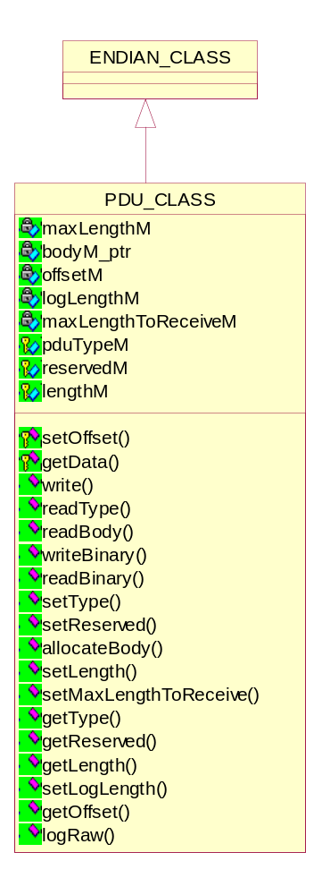
Figure 24 Class diagram of PDU
The DICOM UL protocol consists of seven Protocol Data Units:
a) A-ASSOCIATE-RQ PDU
b) A-ASSOCIATE-AC PDU
c) A-ASSOCIATE-RJ PDU
d) P-DATA-TF PDU
e) A-RELEASE-RQ PDU
f) A-RELEASE-RP PDU
g) A-ABORT PDU

Setting/Getting the Offset Value
void setOffset(UINT32 offset);
UINT32 getOffset();

Setting/Getting the Called AE Title
BYTE* getData();

Reading the data from PDU Body
INT readBinary(BYTE *, UINT);

Setting/Getting the PDU Type
void setType(BYTE type);
BYTE getType();

Setting/Getting the reserved bytes of PDU
void setReserved(BYTE reserved);
BYTE getReserved();

Setting/Getting the actual PDU length
bool setLength(UINT32);
UINT32 getLength();

Writing PDU to socket
bool write(BASE_SOCKET_CLASS*);
Return value | Explanation
true | The operation is successful.
false | The operation is failed.

Reading PDU Type from socket
bool readType(BASE_SOCKET_CLASS*);
Return value | Explanation
true | The operation is successful.
false | The operation is failed.

Reading PDU Body from socket
virtual bool readBody(BASE_SOCKET_CLASS*);
Return value | Explanation
true | The operation is successful.
false | The operation is failed.

Writing data to PDU Body
bool writeBinary(const BYTE *, UINT);
Return value | Explanation
true | The operation is successful.
false | The operation is failed.

Setting the PDU maximum length
bool allocateBody(UINT32);
Return value | Explanation
true | The operation is successful.
false | The operation is failed.

Logging the Raw PDU data
void logRaw(LOG_CLASS*);

Detailed Design of Data Transfer class
The DATA_TF_PDU_CLASS will be derived from the PDU_CLASS and will provide access to the PDV data including the Presentation Context ID and Message Control Header. The Presentation Context ID value should correspond with the ID stored for one of the negotiated SOP Classesand this provides access to the Endian-ness of the encoded data. The Message Control Header indicates whether the PDV fragment is a Command or Data fragment and whether or not it is the last fragment.
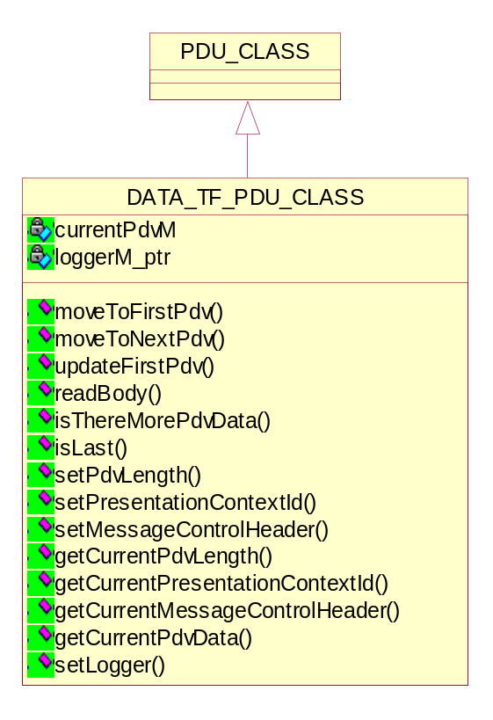
Figure 25 Class diagram of Data transfer PDU

Setting/Getting the Presentation Data Value Length
void setPdvLength(UINT32 length);
UINT32 getCurrentPdvLength();

Setting/Getting the Presentation Context Id
void setPresentationContextId(BYTE pcId);
BYTE getCurrentPresentationContextId();

Setting/Getting the Message Control Header
void setMessageControlHeader(BYTE messageControlHeader);
BYTE getCurrentMessageControlHeader();

Getting the current Presentation Data Value
BYTE *getCurrentPdvData();

Setting the Logger
void setLogger(LOG_CLASS *logger_ptr);

Move index to first PDV in PDU
bool moveToFirstPdv(LOG_CLASS *logger_ptr = NULL);
Return value | Explanation
true | The operation is successful.
false | The operation is failed.

Move index to next PDV in PDU
bool moveToNextPdv(LOG_CLASS *logger_ptr = NULL);
Return value | Explanation
true | The operation is successful.
false | The operation is failed.

Update the first PDV data in the PDU
bool updateFirstPdv(UINT32, BYTE, BYTE);
Return value | Explanation
true | The operation is successful.
false | The operation is failed.

Read P-DATA-TF PDU Body from socket
bool readBody(BASE_SOCKET_CLASS*);
Return value | Explanation
true | The operation is successful.
false | The operation is failed.

Check if the PDU contains more PDV after current offset
bool isThereMorePdvData();
Return value | Explanation
true | The operation is successful.
false | The operation is failed.

Check if PDU contains either the last Command or Dataset PDV
bool isLast();
Return value | Explanation
true | The operation is successful.
false | The operation is failed.

Detailed Design of Network Transfer class
The NETWORK_TF_CLASS will be implemented as an array of DATA_TF_PDU_CLASS. The NETWORK_TF_CLASS::readBinary( ) and NETWORK_TF_CLASS::writeBinary( ) methods will be used to read and write the contents of the DATA_TF_PDU_CLASS array.
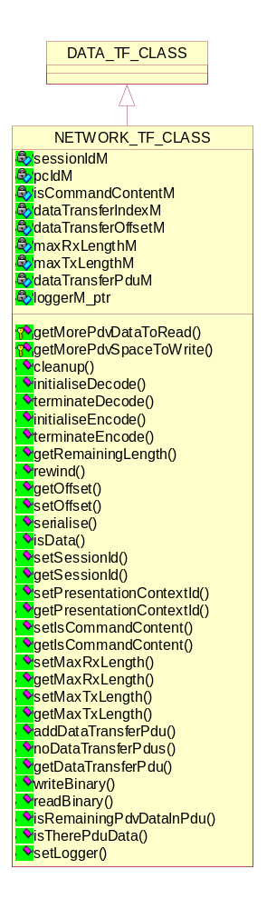
Figure 26 Class diagram of Network Transfer

Setting/Getting the Command Content
void setIsCommandContent(bool isCommandContent);
bool getIsCommandContent();

Setting/Getting the Presentation Context Id
void setPresentationContextId(BYTE pcId);
BYTE getPresentationContextId();

Setting/Getting the Session ID
void setSessionId(int sessionId);
int getSessionId();

Setting/Getting the Maximum RX Length
void setMaxRxLength(UINT32 length);
UINT32 getMaxRxLength();

Setting/Getting the Maximum TX Length
void setMaxTxLength(UINT32 length);
UINT32 getMaxTxLength();

Add the Data Transfer PDU
void addDataTransferPdu(DATA_TF_PDU_CLASS *dataTransferPdu_ptr);

Read data from underlying Data Transfer PDUs
INT readBinary(BYTE *, UINT);

Setting/Getting the current data transfer offset
UINT getOffset();
bool setOffset(UINT);

Setting the Logger
void setLogger(LOG_CLASS *logger_ptr);

Initialising decode from data transfer PDUs
bool initialiseDecode(bool);
Return value | Explanation
true | The operation is successful.
false | The operation is failed.

Terminating decode from data transfer PDUs
bool terminateDecode();
Return value | Explanation
true | The operation is successful.
false | The operation is failed.

Initialising encoding to data transfer PDUs
bool initialiseEncode();
Return value | Explanation
true | The operation is successful.
false | The operation is failed.

Terminating encoding to data transfer PDUs
bool terminateEncode();
Return value | Explanation
true | The operation is successful.
false | The operation is failed.

Check for PDV data in the PDU
bool isRemainingPdvDataInPdu(bool*);
Return value | Explanation
true | The operation is successful.
false | The operation is failed.

Check if any PDU data is available
bool isTherePduData();
Return value | Explanation
true | The operation is successful.
false | The operation is failed.

Move read indexes to next PDU / PDV containing data
bool getMorePdvDataToRead();
Return value | Explanation
true | The operation is successful.
false | The operation is failed.

Set the current PDU length
bool getMorePdvSpaceToWrite();
Return value | Explanation
true | The operation is successful.
false | The operation is failed.

Rewind the data transfer index by the length given
bool rewind(UINT);
Return value | Explanation
true | The operation is successful.
false | The operation is failed.

Serialize the data transfer PDVs to the given file
bool serialise(string, bool);
Return value | Explanation
true | The operation is successful.
false | The operation is failed.

Check if there is still data in data transfer PDUs
bool isData();
Return value | Explanation
true | The operation is successful.
false | The operation is failed.

Detailed Design of Presentation context classes
A Presentation Context defines the presentation of the data on an Association. It provides a lower level of negotiation and one or more Presentation Contexts can be offered and accepted per Association.
A Presentation Context consists of three components, a Presentation Context ID, an Abstract Syntax Name, and a list of one or more Transfer Syntax Names.
Only one Abstract Syntax shall be offered per Presentation Context. However, multiple Transfer Syntaxes may be offered per Presentation Context, but only one shall be accepted.
For each SOP Class or Meta SOP Class a Presentation Context must be negotiated such that this Presentation Context supports the associated Abstract Syntax and a suitable Transfer Syntax. Presentation Contexts will be identified within the scope of a specific association by a Presentation Context ID.

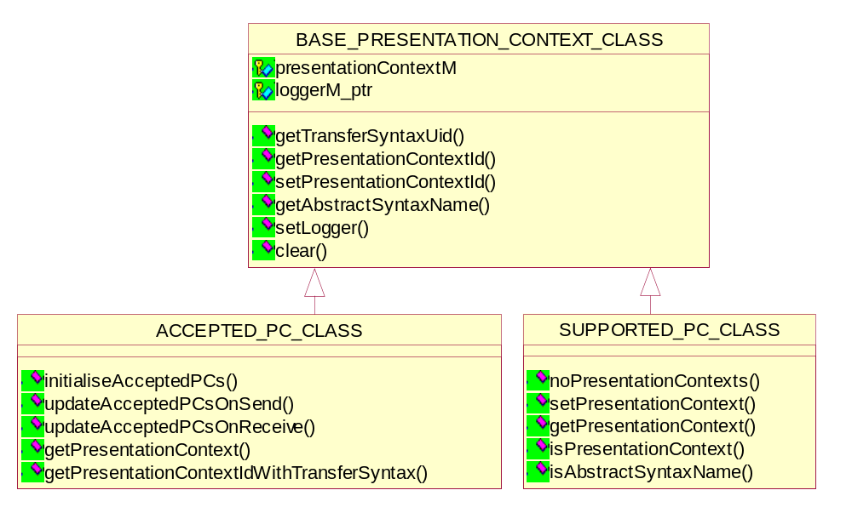
Figure 27 Diagram of Presentation Context classes

Base Presentation Context Class

Setting the Logger
void setLogger(LOG_CLASS *logger_ptr);

Searching the Presentation Contexts for a matching Abstract Syntax Name
void setPresentationContextId(int, BYTE);
BYTE getPresentationContextId(UID_CLASS);
The pcId of the match is returned

Searching the Presentation Contexts for a matching pcId
bool getAbstractSyntaxName(BYTE, UID_CLASS&);
Return value | Explanation
true | The operation is successful.
false | The operation is failed.
The Abstract Syntax of the match is returned.

Searching the Presentation Contexts for a matching pcId
bool getTransferSyntaxUid(BYTE, UID_CLASS&);
Return value | Explanation
true | The operation is successful.
false | The operation is failed.
The Transfer Syntax of the match is returned.

Clearing all presentation contexts
void clear();

Supported Presentation Context Class

Determining the size of Presentation Context
int noPresentationContexts();

Adding the presentation context to the list
void setPresentationContext(UID_CLASS, UID_CLASS);
bool getPresentationContext(int, UID_CLASS&, UID_CLASS&);

Returning the indexed presentation context
bool getAbstractSyntaxName(BYTE, UID_CLASS&);
Return value | Explanation
true | The operation is successful.
false | The operation is failed.

Checking the list of accepted presentation contexts
int isPresentationContext(UID_CLASS, UID_CLASS);

Accepted Presentation Context Class
The ACCEPTED_PC_CLASS will be used to store the result of the association request/accept activity. It will maintain a list of accepted presentation contexts for the association.

Initialize the Accepted Presentation Context list
void initialiseAcceptedPCs(ASSOCIATE_RQ_CLASS*);

Update the Associate Accept
void updateAcceptedPCsOnSend(ASSOCIATE_AC_CLASS*);
This is done to ensure that the SCU receives a complete and correct Associate Accept. Any additional Presentation Contexts are refused.

Update the received Associate Accept in the Accepted PC list
void updateAcceptedPCsOnReceive(ASSOCIATE_AC_CLASS*);

Getting the Presentation Context Items
void getPresentationContext(ASSOCIATE_AC_CLASS*);

Getting the presentation context id
int getPresentationContextIdWithTransferSyntax(UID_CLASS, UID_CLASS);

Presentation Context Request class
This class represents the requested Presentation Context.
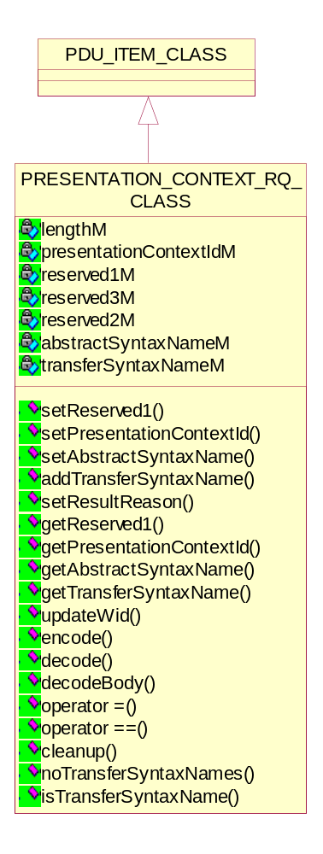
Figure 28 Class diagram of Requested Presentation Context

Setting/Getting the reserved byte value
void setReserved1(BYTE value);
BYTE getReserved1();

Setting/Getting the Presentation Context Id
void setPresentationContextId(BYTE id);
BYTE getPresentationContextId();

Setting/Getting the Abstract Syntax Name
void setAbstractSyntaxName(ABSTRACT_SYNTAX_NAME_CLASS& name)
UID_CLASS& getAbstractSyntaxName();

Setting/Getting the Transfer Syntax Name
UID_CLASS& getTransferSyntaxName(UINT i);
void addTransferSyntaxName(TRANSFER_SYNTAX_NAME_CLASS& name);
void addTransferSyntaxName(UID_CLASS &uid);

Encoding Requested Presentation Context as PDU
bool encode(PDU_CLASS&);
Return value | Explanation
true | The operation is successful.
false | The operation is failed.

Decoding Requested Presentation Context from PDU
bool decode(PDU_CLASS&);
Return value | Explanation
true | The operation is successful.
false | The operation is failed.

Getting PDU length
UINT32 getLength();

Assignment operator
bool operator = (PRESENTATION_CONTEXT_RQ_CLASS&);
Return value | Explanation
true | The operation is successful.
false | The operation is failed.

Equality operator
bool operator == (PRESENTATION_CONTEXT_RQ_CLASS&);
Return value | Explanation
true | The operation is successful.
false | The operation is failed.

Updating the object in Warehouse
bool updateWid(BASE_WAREHOUSE_ITEM_DATA_CLASS*);
Return value | Explanation
true | The operation is successful.
false | The operation is failed.

Decoding sub-item from PDU
bool decodeBody(PDU_CLASS&);
Return value | Explanation
true | The operation is successful.
false | The operation is failed.

Presentation Context Accept class
This class represents the accepted Presentation Context.
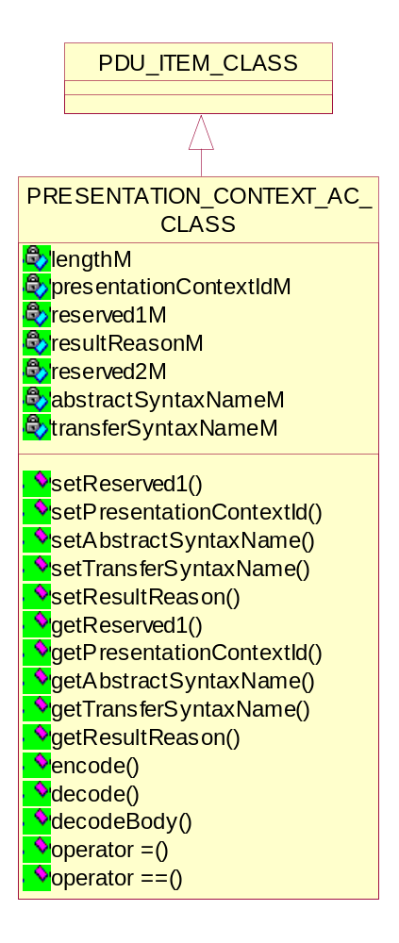
Figure 29 Class diagram of Accepted Presentation Context

Setting/Getting the reserved byte value
void setReserved1(BYTE value);
BYTE getReserved1();

Setting/Getting the Presentation Context Id
void setPresentationContextId(BYTE id);
BYTE getPresentationContextId();

Setting/Getting the Abstract Syntax Name
void setAbstractSyntaxName(ABSTRACT_SYNTAX_NAME_CLASS& name)
UID_CLASS& getAbstractSyntaxName()

Setting/Getting the Transfer Syntax Name
UID_CLASS& getTransferSyntaxName(UINT i);
void addTransferSyntaxName(TRANSFER_SYNTAX_NAME_CLASS& name);
void addTransferSyntaxName(UID_CLASS &uid);

Encoding Accepted Presentation Context as PDU
bool encode(PDU_CLASS&);
Return value | Explanation
true | The operation is successful.
false | The operation is failed.

Decoding Accepted Presentation Context from PDU
bool decode(PDU_CLASS&);
Return value | Explanation
true | The operation is successful.
false | The operation is failed.

Getting PDU length
UINT32 getLength();

Assignment operator
bool operator = (PRESENTATION_CONTEXT_RQ_CLASS&);
Return value | Explanation
true | The operation is successful.
false | The operation is failed.

Equality operator
bool operator == (PRESENTATION_CONTEXT_RQ_CLASS&);
Return value | Explanation
true | The operation is successful.
false | The operation is failed.

Detail Design of Receive Message Union class
The Receive Message Union class aggregates all PDU types (DIMSE & DULP) objects. It get/set all the objects.
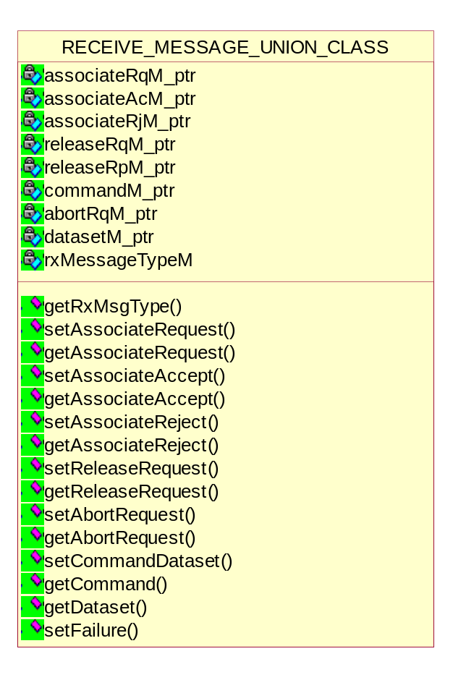
Figure 30 Class diagram of Receive Message Union

Setting/Getting the received message as an Associate Request
void setAssociateRequest(ASSOCIATE_RQ_CLASS*);
ASSOCIATE_RQ_CLASS *getAssociateRequest();

Setting/Getting the received message as an Associate Accept
void setAssociateAccept(ASSOCIATE_AC_CLASS*);
ASSOCIATE_AC_CLASS *getAssociateAccept();

Setting/Getting the received message as an Associate Reject
void setAssociateReject(ASSOCIATE_RJ_CLASS*);
ASSOCIATE_RJ_CLASS *getAssociateReject();

Setting/Getting the received message as a Release Request
void setReleaseRequest(RELEASE_RQ_CLASS*);
RELEASE_RQ_CLASS *getReleaseRequest();

Setting/Getting the received message as a Release Responses
void setReleaseResponse(RELEASE_RP_CLASS*);
RELEASE_RP_CLASS *getReleaseResponse();

Setting/Getting the received message as an Abort Request
void setAbortRequest(ABORT_RQ_CLASS*);
ABORT_RQ_CLASS *getAbortRequest();

Setting/Getting the received message as a DICOM Message
void setCommandDataset(DCM_COMMAND_CLASS*, DCM_DATASET_CLASS*);
DCM_COMMAND_CLASS *getCommand();
DCM_DATASET_CLASS *getDataset();

Setting/Getting the received message as a failure
void setFailure();

Detail Design of Socket classes
The use of the secure transport is optional and must be turned on in the configuration of the session. By default, a new session will not use secure sockets.
The following protocols are supported for secure transport:
- Transport Layer Security (TLS). TLS version 1.0 required by DICOM [DICOM, 3.15, B.1] and IHE [IHE2, 4.32.4.1.2].
- Secure Socket Layer (SSL). SSL version 3.0 required for compatibility with different implementations.

Base Socket class
It is an abstract base class for all the socket interfaces. It has various virtual functions, which are implemented in the classes derived by Base_Socket_class.

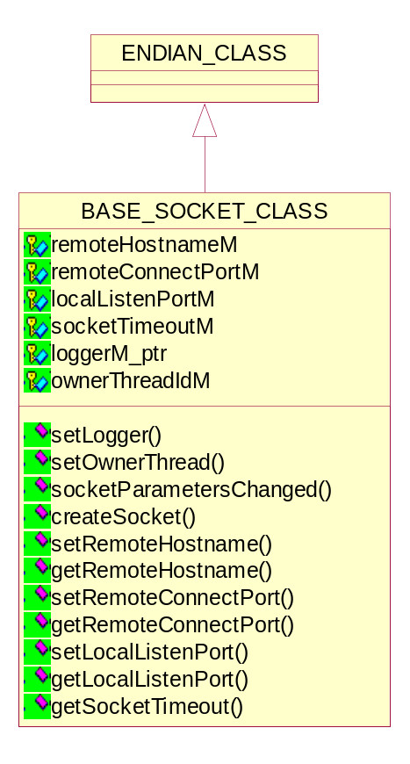
Figure 31 Class diagram of Base Socket

Virtual functions
virtual bool connect() = 0;
virtual bool listen() = 0;
virtual bool accept(BASE_SOCKET_CLASS** acceptedSocket_ptr_ptr) = 0;
virtual void close() = 0;
virtual bool isConnected() = 0;
virtual bool isSecure() = 0;
virtual bool socketParametersChanged(
const SOCKET_PARAMETERS& socketParams);

Setting the logger to save the Logger address
void setLogger(LOG_CLASS*);

Setting the thread to the thread ID
void setOwnerThread(THREAD_TYPE tid)

Setting/Getting Hostname if the socket is used as a client
void setRemoteHostname(string hostname);
string getRemoteHostname();

Setting/Getting the port to connect on if the socket is used as a client
void setRemoteConnectPort(UINT16 port);
UINT16 getRemoteConnectPort();

Setting/Getting the port to listen on it the socket is used as a server
void setLocalListenPort(UINT16 port);
UINT16 getLocalListenPort();

Setting/Getting the socket timeout in seconds
int getSocketTimeout()

Socket class
This class is used to handle the standard (non-secure) socket interface.

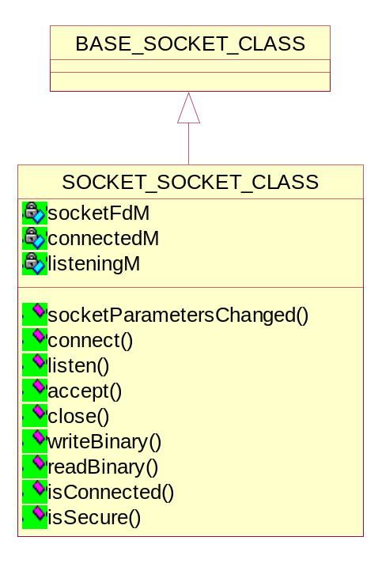
Figure 32 Class diagram of Socket

Setting up connection to the remote host
virtual bool connect();

Return value | Explanation
true | The operation is successful.
false | The operation is failed.

Setting up the listen port
virtual bool listen();

Return value | Explanation
true | The operation is successful.
false | The operation is failed.

Accepting connection from listen socket
virtual bool accept(BASE_SOCKET_CLASS** acceptedSocket_ptr_ptr);

Return value | Explanation
true | The operation is successful.
false | The operation is failed.

Closing socket down
virtual void close();

Return value | Explanation
true | The operation is successful.
false | The operation is failed.

Writing given data to socket
Virtual bool writeBinary(const BYTE*, UINT);

Return value | Explanation
true | The operation is successful.
false | The operation is failed.

Reading data from socket to given buffer
virtual INT readBinary(BYTE*, UINT);

Return value | Explanation
true | The operation is successful.
false | The operation is failed.
It blocks until all of the requested data is read or a timeout occurs.

Checking the connection
virtual bool isConnected();

Return value | Explanation
true | The operation is successful.
false | The operation is failed.

Checking the security
virtual bool isSecure();

Return value | Explanation
true | The operation is successful.
false | The operation is failed.

Checking socket parameters
virtual bool socketParametersChanged(const SOCKET_PARAMETERS& socketParams);

Return value | Explanation
true | The operation is successful.
false | The operation is failed.

Socket Parameters Structure
This structure contains the attributes needed to construct a socket class. It is used to pass the socket parameters between the session class (where they are stored) to the socket classes (where they are used).

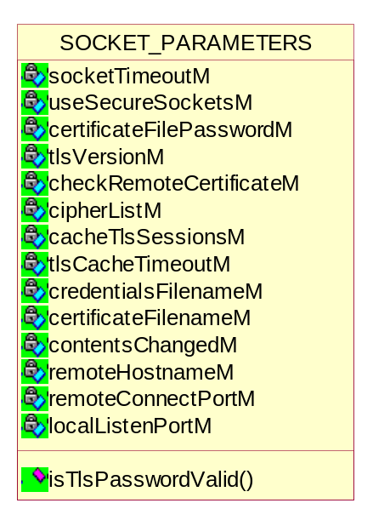
Figure 33 Diagram of Socket Parameters structure

Socket Parameters
- Remote Hostname: It represents Hostname if the socket is used as a client.
- Remote Connect Port: It represents Port to connect on if the socket is used as a client.
- Local Listen Port: It represents Port to listen on it the socket is used as a server.
- Socket Timeout: The socket timeout in seconds.
- UseSecureSockets: It indicates that secure sockets should be used.
- Certificate File Password: It is not stored in the session file. When the file is opened this value is asked from the user if needed.
- TLS Cache Timeout: It represents session cache timeout time used by the TLS server.
- ContentsChanged: It indicates that the contents of one of the files have changed.

Determining if the TLS password is valid
bool isTlsPasswordValid(bool& unencryptedKeyFound);

Return value | Explanation
true | The operation is successful i.e On any error condition it returns true.
false | The operation is failed.

TLS Socket class
This class is used to handle the TLS/SSL (secure) socket interface.
TLS is a widely used standard security protocol. It is based on SSL. TLS v1.0 is a minor upgrade of SSL v3.0. TLS is an additional layer added right above TCP/IP. This allows the main part of an application to have no changes when switching to secure sockets.
TLS is a framework that puts together other security methods to provide a secure transport package. For each of the functions, TLS supports many security methods. Which methods are used is negotiated at connection time. The TLS negotiation is initiated after the socket is opened but before any data is sent.
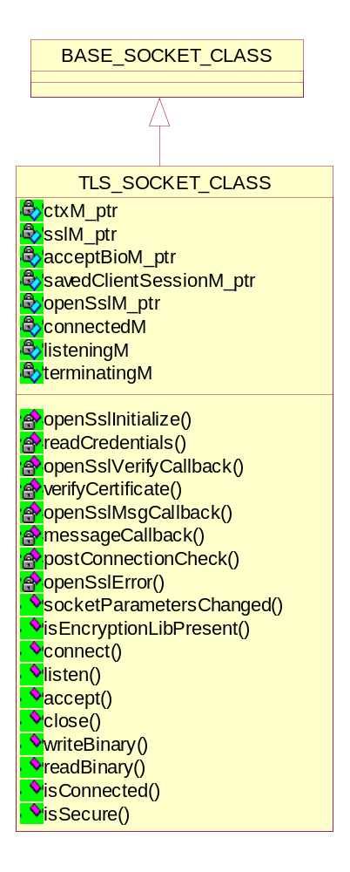
Figure 34 Class diagram of TLS Socket

Initializing the OpenSSL library
bool openSslInitialize();

Return value | Explanation
true | The operation is successful i.e if it is initialized.
false | The operation is failed.

Reading the credentials file
bool readCredentials(SSL_CTX* ctx_ptr);

Return value | Explanation
true | The operation is successful i.e if the credential file is read successfully.
false | The operation is failed.

Callback OpenSSL
static int openSslVerifyCallback(int ok, X509_STORE_CTX* store);
It is used to request further verification of the received certificate. This is static function used to call the correct instantiated method.

Verification of the received certificate
int verifyCertificate(int ok, X509_STORE_CTX* store_ptr);
It is an instantiated method used by the OpenSSL callback to request further verification of the received certificate. No further verification of the certificate is done, but use this to obtain detailed failure information.

Callback from OpenSSL when a SSL message is sent/ received
static void openSslMsgCallback(int write_p, int version, int
content_type, const void *buf, size_t len, SSL *ssl_ptr, void *this_ptr);
This is static function used to call the correct instantiated method.

Printing debug information
void messageCallback(int write_p, int version, int content_type, const void *buf, size_t len, SSL *ssl_ptr);
It is an instantiated method used by the OpenSSL callback to print debug information about each of the SSL messages.

Performing checks after the connection is made
long postConnectionCheck(SSL* ssl_ptr);
This is done to insure everything is working fine.

Generating an error message for the current Open SSL error
void openSslError(UINT32 logLevel, const char *format_ptr, ...);
void openSslError(const char *format_ptr, ...)

Checking if the OpenSSL DLLs are present and loads them
static bool isEncryptionLibPresent();

Checking the difference in socket parameters
virtual bool socketParametersChanged(const SOCKET_PARAMETERS& socketParams);

Return value | Explanation
true | The operation is successful.
false | The operation is failed.

Setting up connection to the remote host
virtual bool connect();

Return value | Explanation
true | The operation is successful.
false | The operation is failed.

Setting up the listen port
virtual bool listen();

Return value | Explanation
true | The operation is successful.
false | The operation is failed.

Accepting connection from listen socket
virtual bool accept(BASE_SOCKET_CLASS** acceptedSocket_ptr_ptr);

Return value | Explanation
true | The operation is successful.
false | The operation is failed.

Closing socket down
virtual void close();

Return value | Explanation
true | The operation is successful.
false | The operation is failed.

Writing given data to socket
virtual bool writeBinary(const BYTE*, UINT);

Return value | Explanation
true | The operation is successful.
false | The operation is failed.

Reading data from socket to given buffer
virtual INT readBinary(BYTE*, UINT);

Return value | Explanation
true | The operation is successful.
false | The operation is failed.
It blocks until all of the requested data is read or a timeout occurs.

Checking the connection
virtual bool isConnected();

Return value | Explanation
true | The operation is successful.
false | The operation is failed.

Checking the security
virtual bool isSecure();

Return value | Explanation
true | The operation is successful.
false | The operation is failed.

Open SSL class
This class provides an interface to the OpenSSL library. This class loads the OpenSSL DLLs (libeay32.dll and ssleay32.dll) and sets up function pointers to all of the used functions. It also initializes the library and provides additional interface functions. This class is a singleton.
During communication over TCP/IP, the OpenSSL protocols may be used. This requires the use of certificates (public keys) and credentials (private keys). The classes within this namespace are used to set the certificates and credentials for the validation test session.
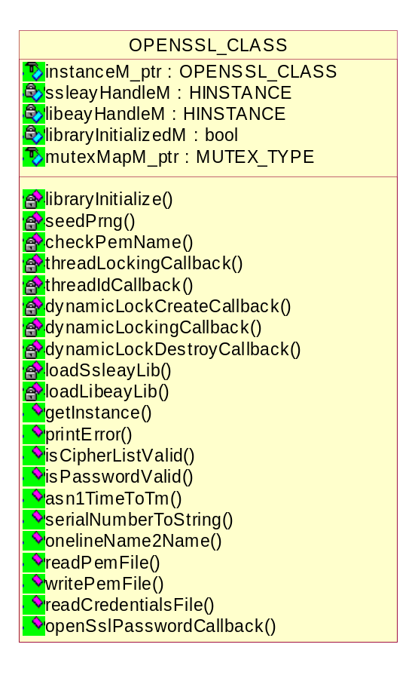
Figure 35 Class diagram of Open SSL

Initializing and loadingthe OpenSSL libraries
bool libraryInitialize();
bool loadSsleayLib();
bool loadLibeayLib();

Seeding the OpenSSL random number generator
void seedPrng();

Generating an error message for the current Open SSL error
void printError(LOG_CLASS* logger_ptr, UINT32 logLevel, const char *format_ptr, ...);

Checking for Cipher list & password
bool isCipherListValid(const char* cipherList);
bool isPasswordValid(const char* filename, const char* password, bool& unencryptedKeyFound);

Reading a PEM file
DVT_STATUS readPemFile(const char* filename_ptr,
STACK_OF(X509_INFO)** pem_ptrptr,
pem_password_cb *passwordCallback_ptr,
void *passswordCbUserData_ptr,
LOG_CLASS* logger_ptr,
bool* unencryptedKeyFound_ptr);

Writing a PEM file
bool writePemFile(const char* filename_ptr,
STACK_OF(X509_INFO)* pem_ptr,
const char* password_ptr,
LOG_CLASS* logger_ptr);

Reading a credential file
DVT_STATUS readCredentialsFile(const char* filename_ptr,
EVP_PKEY** rsaPrivateKey_ptrptr,
STACK_OF(X509)** rsaCertChain_ptrptr,
EVP_PKEY** dsaPrivateKey_ptrptr,
STACK_OF(X509)** dsaCertChain_ptrptr,
pem_password_cb *passwordCallback_ptr,
void *passswordCbUserData_ptr,
LOG_CLASS* logger_ptr);

Callback functions from Open SSL
void threadLockingCallback(int mode, int n, const char* file,
int line);
unsigned long threadIdCallback();
struct CRYPTO_dynlock_value* dynamicLockCreateCallback(
const char *file, int line);
void dynamicLockingCallback(int mode,
CRYPTO_dynlock_value* lock_ptr,
const char* file, int line);
void dynamicLockDestroyCallback(CRYPTO_dynlock_value* lock_ptr,
const char* file, int line);
DH* tmpDhCallback(SSL*, int, int keylength);
int openSslPasswordCallback(char* password, int buffersize, int, void* pwd);

Detail Design of Certificate classes
A digitally signed document that identifies an entity and provides that entity’s public key. Every certificate is traceable to a self-signed certificate through its certificate chain.

Certificate class
This class is used to contain certificate data.

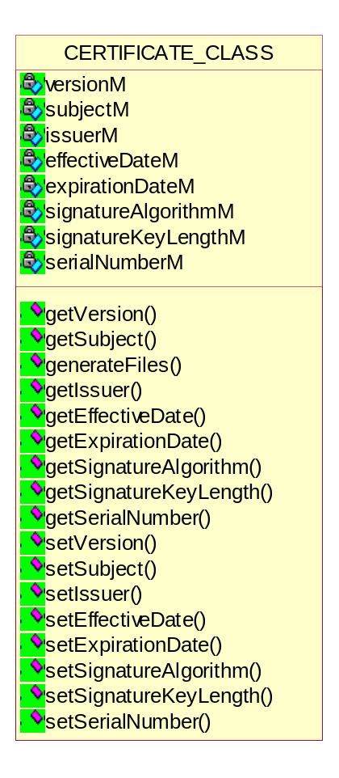
Figure 36 Class diagram of Certificate

Setting/Getting the Version
long getVersion();
void setVersion(long version);

Setting/Getting the subject
const char* getSubject();
void setSubject(const char* subject);

Setting/Getting the Issuer
const char* getIssuer();
void setIssuer(const char* issuer);

Setting/Getting the Effective Date
struct tm* getEffectiveDate();
void setEffectiveDate(struct tm& effectiveDate);

Setting/Getting the Expiration date.
struct tm* getExpirationDate();
void setExpirationDate(struct tm& expirationDate);

Setting/Getting the value of Signature algorithm.
const char* getSignatureAlgorithm();
void setSignatureAlgorithm(const char* signatureAlgorithm);

Setting/Getting the length of Signature key .
int getSignatureKeyLength();
void setSignatureKeyLength(int signatureKeyLength);

Setting/Getting the serial number of the certificate.
const char* getSerialNumber();
void setSerialNumber(const char* serialNumber);

Certificate File class
This class is used to read and manipulate certificate files.

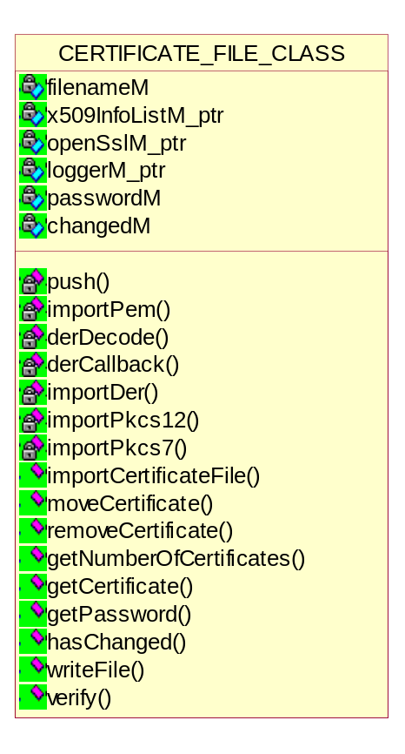
Figure 37 Class diagram of Certificate File

Push the certificate/private key onto the certificate stack
bool push(X509*&);
bool push(EVP_PKEY*&);

Return value | Explanation
true | The operation is successful.
false | The operation is failed.

Importing certificates from a PEM formatted file
DVT_STATUS importPem(const char* filename, bool certificatesOnly, const char* password);
It returns MSG_OK, MSG_ERROR, MSG_FILE_NOT_EXIST, MSG_NO_VALUE, MSG_INVALID_PASSWORD.

Callback to determine the type of the DER data
static char* derCallback(CERTIFICATE_FILE_CLASS* certFileClass_ptr, unsigned char **buf_ptrptr, long length);

Determining the type of the DER data and decode it
char* derDecode(unsigned char **buf_ptrptr, long length);

Importing certificates from a PEM formatted file
DVT_STATUS importDer(const char* filename, bool certificatesOnly, const char* password);
It returns MSG_OK, MSG_ERROR, MSG_FILE_NOT_EXIST, MSG_NO_VALUE
Note: DER does not support encryption, so MSG_INVALID_PASSWORD will never be returned.

Importing certificates from a PKCS#12 formatted file
DVT_STATUS importPkcs12(const char* filename, bool certificatesOnly, const char* password);

Importing certificates from a PKCS#7 formatted file
DVT_STATUS importPkcs7(const char* filename, bool certificatesOnly, const char* password);

Importing the given certificate file
DVT_STATUS importCertificateFile(const char* filename, bool certificatesOnly, const char* password);

Moving the certificate at the given index to the new index
bool moveCertificate(int oldIndex, int newIndex);

Return value | Explanation
true | The operation is successful i.e On any error condition it returns true
false | The operation is failed.
The new Index will be the index the certificate will be at after the move is complete.

Removing the certificate at the given index
bool removeCertificate(int index);

Return value | Explanation
true | The operation is successful i.e On any error condition it returns true
false | The operation is failed.

Getting the number of certificates available
int getNumberOfCertificates();

Getting the certificate at the given index
CERTIFICATE_CLASS* getCertificate(int index);

Writing the certificate information to the file
bool writeFile(const char* password);
Return value | Explanation
true | The operation is successful i.e On any error condition it returns true
false | The operation is failed.

Verifying the contents of the file
bool verify(bool isCredentials, char** msg_ptrptr);
Return value | Explanation
true | The operation is successful i.e On any error condition it returns true.
false | The operation is failed.

